Table of Contents

Lab: Module 1 – VSTS Project Management 2

Duration: 3 hours (10-40 mins per exercise) 2

Prerequisite 2

Exercise 1: Setup VSTS Account and 2 Projects 2

Exercise 2: Setup your Custom Processes 9

Exercise 3: Setup your Sprint 18

Exercise 4: Populate your Sprint (Bulk Modify, Templates, Tagging, Linking Stories, etc) 23

Exercise 5: Setup and customize your Board (Add work items) 37

Exercise 6: Logging Bugs, Searching Work Items, Discussions, Attachments, etc 46

Exercise 7: Creating effective Queries 49

Exercise 8: Monitor your Sprint (Dashboards, Wiki, Favorites, Watches, Delivery Plans) 53

Exercise 9: Setup Notifications 66

Exercise 10: PREVIEW Features, Requesting Features, Roadmap 67

Exercise 11: Advanced Scenario: Help the team out with some custom requests! 68

Lab: Module 1 – VSTS Project Management

Duration: 3 hours

Prerequisite

You must have a VSTS account. You can create a free one using a personal or work email by going here: <https://www.visualstudio.com/team-services/> and clicking the blue “Get Started for Free” button. Everyone will use their own personal VSTS account. And, you need an Internet connection.

Exercise 1: Setup Your VSTS Account and 2 Projects (20 mins)

In this lab, we will follow a scenario. You will create the scenario in the steps and each exercise will build upon the previous one, so don’t skip exercises! I will put additional “*Notes*” in italics which give you more information about what is going on but don’t contain any steps to the lab. This is just to help you learn, please take the time to read them and understand 😊.

You work for a restaurant business called “Pho Sizzle Vietnamese Cuisine”. Our restaurant has 2 web teams working on the main website and a mobile team on the mobile app. The 2 web teams are named: “Pho Sho” and “Pho Real”. The mobile team calls themselves: “Mobile Pho(ne)”. We want to make sure they are creating features in sync and that the mobile and web features are released on the same timeline. We will setup their account now. Later in this lab, we will build sprints, populate in work items, tasks, and bugs. Then, we will create Queries, Dashboards, Wikis, and other useful goodies for them to keep organized. Everyone will use their own VSTS account, so they can have the full experience of setting up everything.

Tasks

1. Setup VSTS
2. Go to this URL: <https://www.visualstudio.com/team-services/>
3. Click on “Get Started for Free”. If you do not have an account, please Create one now. You can use a work email or a personal Microsoft account. If you have an account already setup (or an MSDN) please login.
   * 1. *Note: VSTS and TFS are basically the same, except VSTS is constantly updated and kept current and to get new changes you need to manually update your TFS. And, TFS on premises and VSTS is just accessed through the web. If you do not see any of the features I talk about here in your TFS, most likely it is in a newer update of TFS.*
4. You will land on a page that looks like this (except no projects like shown in my screenshot with the arrows and highlights!).

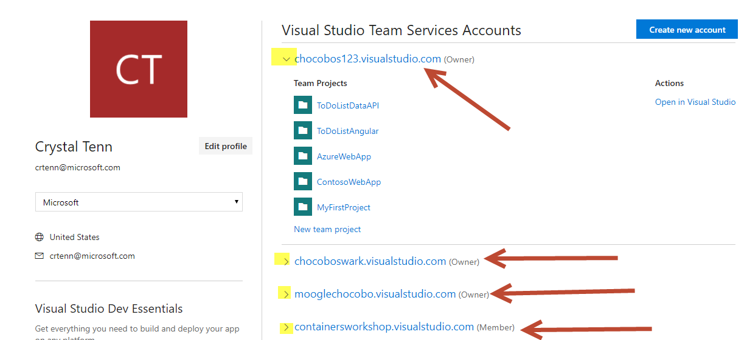

*Note: Each account typically contains multiple team projects. If you have multiple unrelated dev teams, it would be good to make a separate VSTS account for each. For example, let’s say you owned a restaurant business. If you had 3 teams of developers, who worked on 3 separate types of projects: customer-facing restaurant websites, restaurant applications for the employees to manage orders, and an eCommerce online ordering platform. Each of these 3 teams should have their own VSTS page. Also, if different teams have different processes and project settings, they would need to be split up. While you could put all the applications on the same VSTS, this is not the best idea as every person on every team has access to everything even though they shouldn’t. It is also harder to find However, you may want to place all the projects in one VSTS account if it is a small company and all the team members touch all the different applications.*

1. Hit Create New Account on the top right (blue button) to make your own VSTS account.

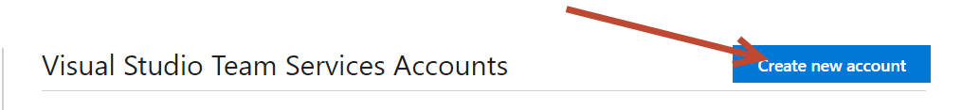

1. The name has to be unique across all existing VSTS accounts. You can name it “PhoSizzle-YOUR-INITIALS” for example. Mine here is called “phosizzle-cat”. Leave the code management as Git. Hit Continue and give it a few minutes to create your acount.

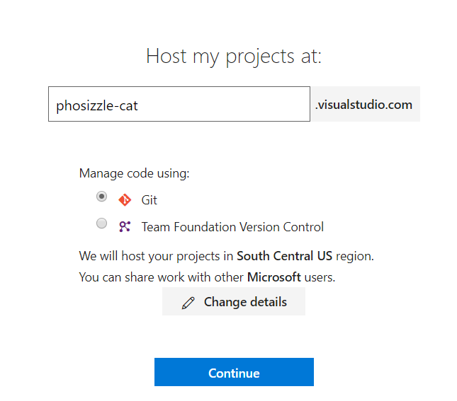

1. You will land on a page like this:

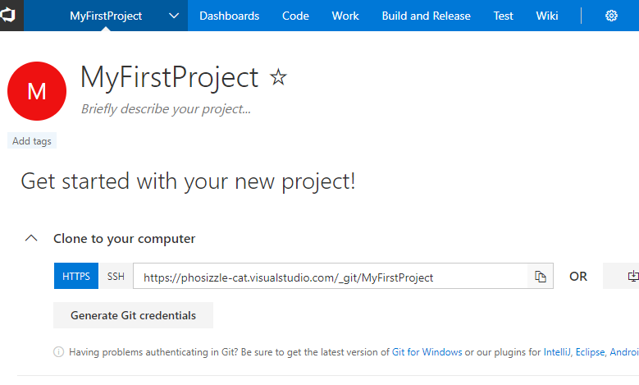

1. Click on the main VSTS logo on the top right.

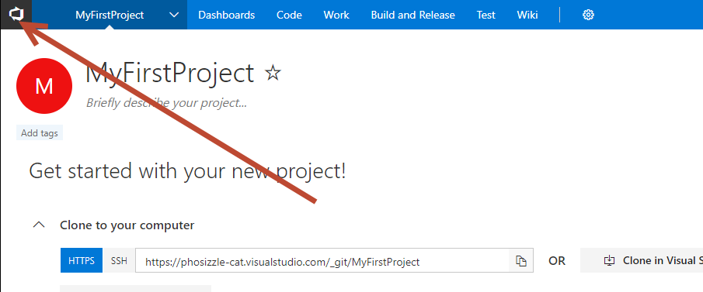

1. You will land on a page like below, click on New Project.

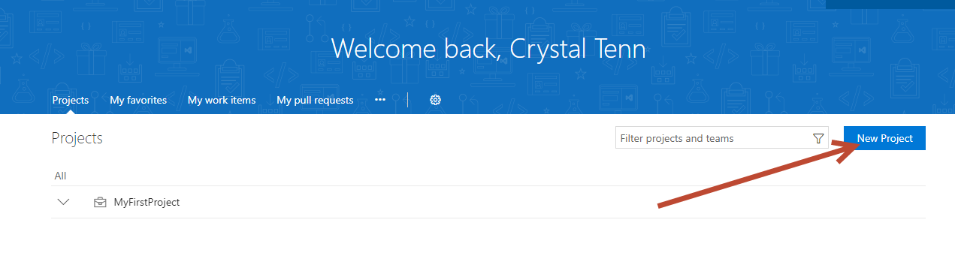

1. I’ll keep it simple and call one PhoSizzleWeb and hit Create (put anything you like in the description):

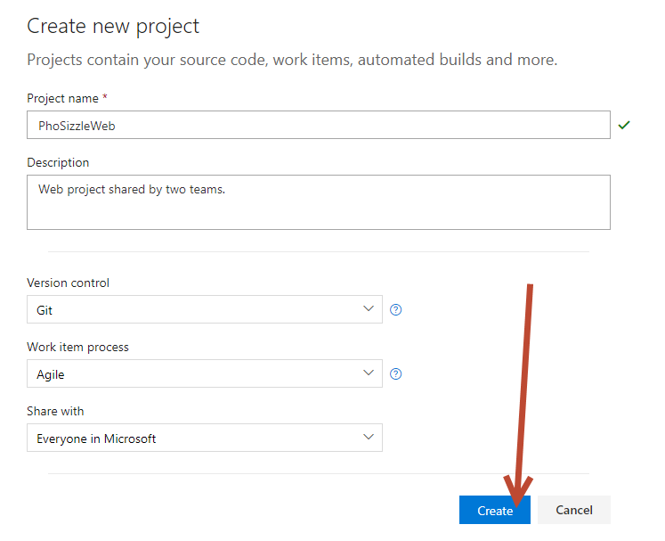

1. When you are done, Click the VSTS logo again. Then, click New Project again to create the Mobile project (put anything you like in the description) and hit Create:

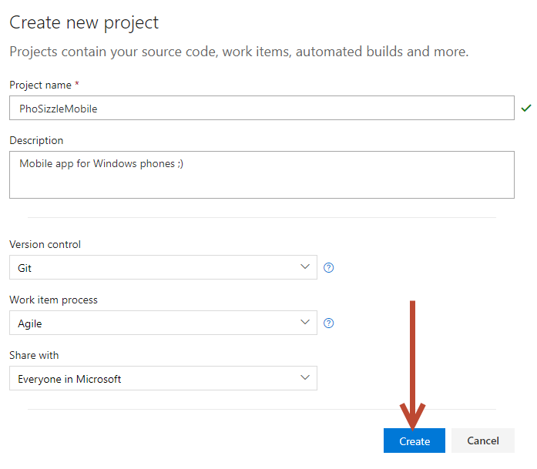

1. Let’s stay on this Mobile project for now. We need to create a team. Click on the name of the PhoSizzleMobile and click New Team.

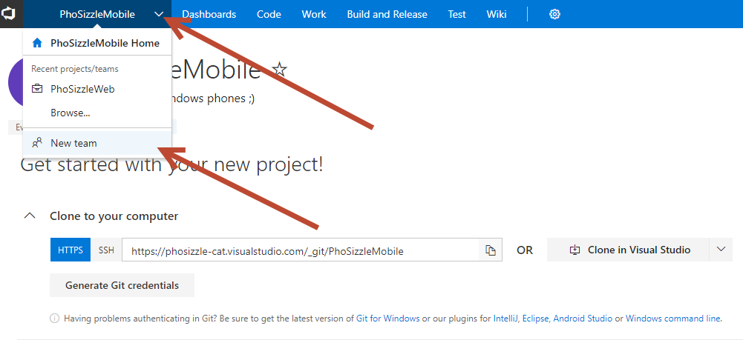

1. Add your Mobile Pho(ne) team. Permissions will stay as Contributor. And you can leave the box checked to create an area path. Hit Create Team when you are done.

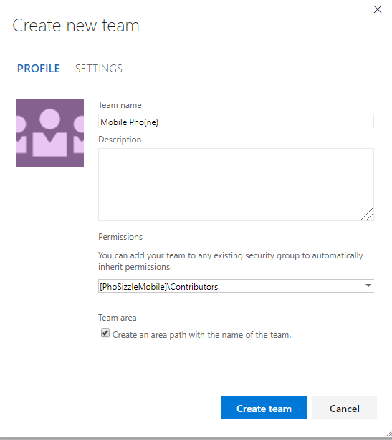

1. Click on the PhoSizzleMobile button on the top to swap to the other project for the PhoSizzleWeb:

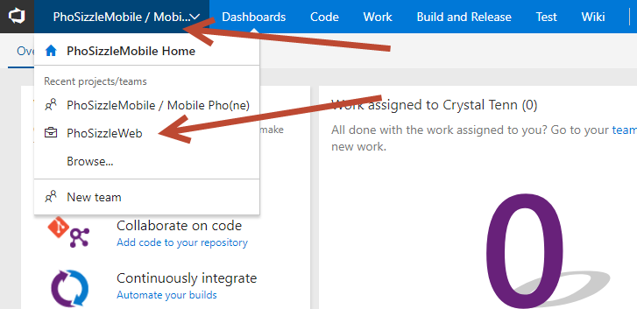

1. You should see PhoSizzle web when you are done swapping over:

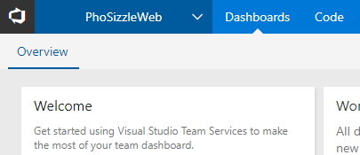

1. Click the dropdown again, and hit New Team:

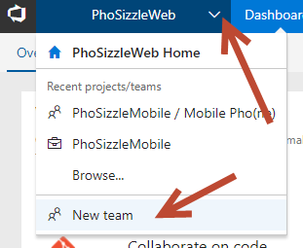

1. Create one Team for Pho Real.

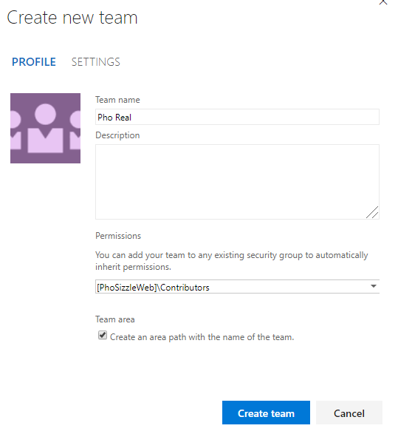

1. Create one Team for Pho Sho.

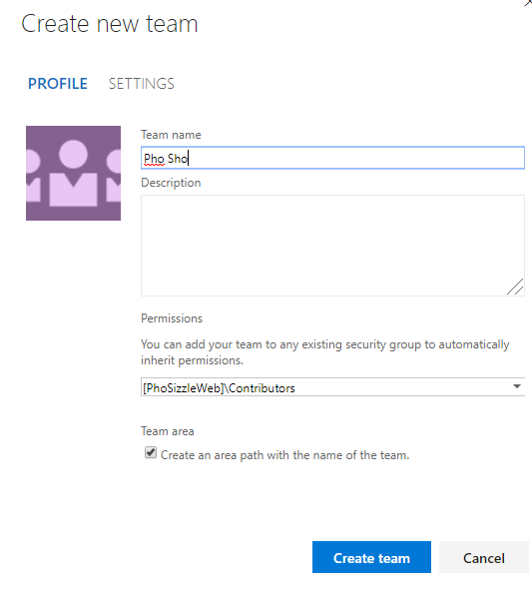

1. Click on the VSTS logo and you should see the following as your Projects!

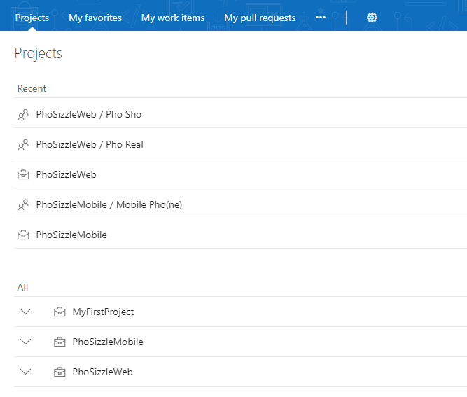

Exercise 2: Setup Your Custom Processes (15 mins)

Now we will setup custom processes for our teams. Our teams have different work flows. The Pho Sho team wants the regular default Agile Process. The team want to work on an Agile Scrum process with customization. Our Mobile Pho(ne) Pho Real team works on a Kanban process, we can easily leave them on a default process and just avoid setting up a sprint schedule for them. All we need to do is setup one custom process for the Mobile team.

We can accommodate that! We will setup custom processes and assign our teams accordingly.

Tasks

1. Setup a Custom Process
2. From the main VSTS homepage, click on the settings gear:

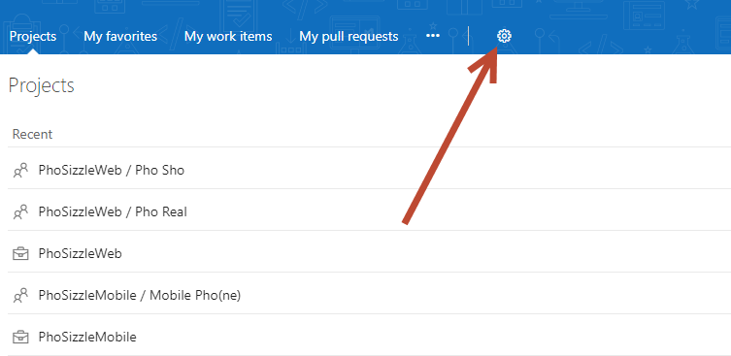

1. Click on the Process tab. Make sure you are in the phosizzle-cat section of VSTS!

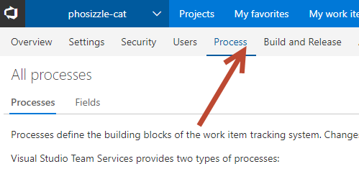

1. You will see the following 3 main default projects. The default 3 cannot be customized at all. Therefore, you need to create a custom process to customize the project so the Mobile team is happy.

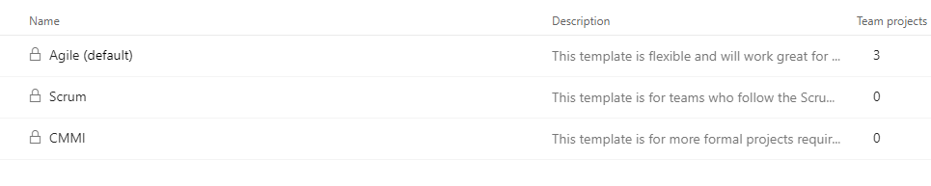

*Note: The three default processes differ mainly in the* ***work item types (WITs)*** *they provide for planning and tracking work. Scrum is the most light-weight and CMMI, which stands for Capability Maturity Model Integration, provides the most support for formal processes and change management.*

*Key differences in documentation here:* [*https://docs.microsoft.com/en-us/vsts/work/work-items/guidance/choose-process*](https://docs.microsoft.com/en-us/vsts/work/work-items/guidance/choose-process)

*Short summary below:*

* *Agile*
  + *-"This template is flexible and will work great for most teams using Agile planning methods, including those practicing Scrum."*
  + *Bugs are not on the backlog*
  + *User stories, but no use cases. More constraint on writing up stories, hard to write nonfunctional requirements.*
* *Scrum*
  + *-"This template is for teams who follow the Scrum methodology and use Scrum terminology."*
  + *Remaining work on Task*
  + *Requirement Type by default (Functional, Technical, Etc)*
* *CMMI:* 
  + *-"This template is for more formal projects requiring a framework for process improvement and an auditable record of decisions."*
  + *is a quality management framework useful for large organizations that need to measure themselves in terms of their overall capability and maturity to demonstrate repeatable quality of software work they do. Organizations can use a mix of software development methods - Agile methods (such as Scrum/ Kanban/ XP/ BDD/ TDD/ etc), 'traditional' methods (Waterfall, Iterative) or a mix (Hybrid Agile), depending on their business needs. They can still use CMMI as an overall governance framework to measure and develop their software capabilities.*

1. Let’s go create a new process off the Agile process. Click the 3 dots on the right of the Agile (default) process type and select Create Inherited Process.

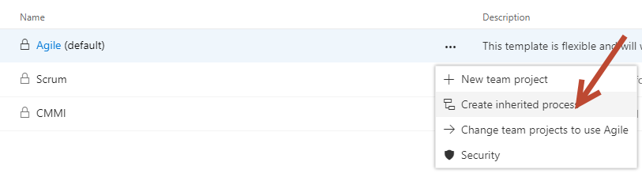

1. I called mine “Custom Agile”, name yours and click Create Process.

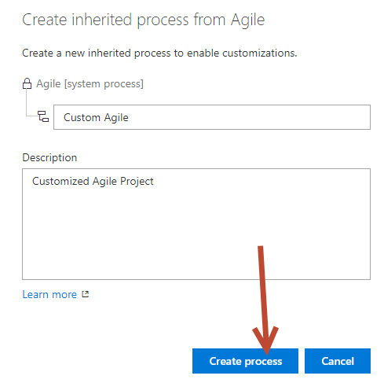

1. Click on the 3 dots of your new Custom Agile process and select “Change team projects to use custom agile”:

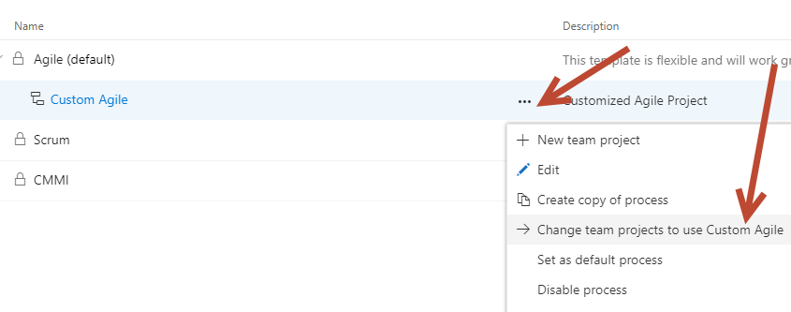

1. Select your mobile team to move, and hit OK.

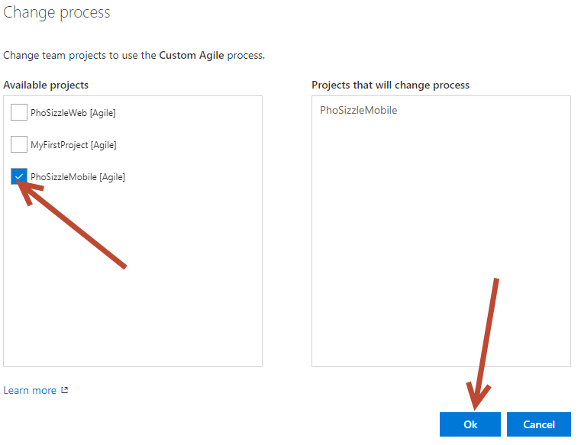

1. You should see 2 projects under Agile now and 1 under the Custom Agile.

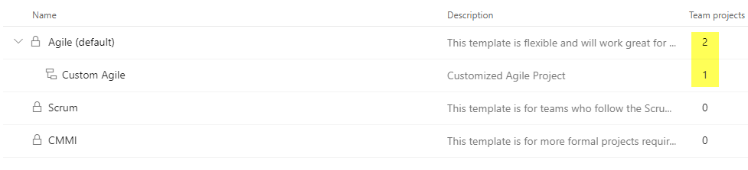

1. Click on the Custom Agile process. Let’s actually go customize a few things…

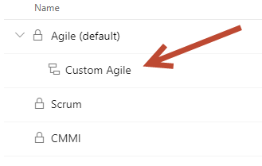

1. On the next landing page, you can see you can add a new Work Item type or edit a current work Item type. Click on the Bug work item.

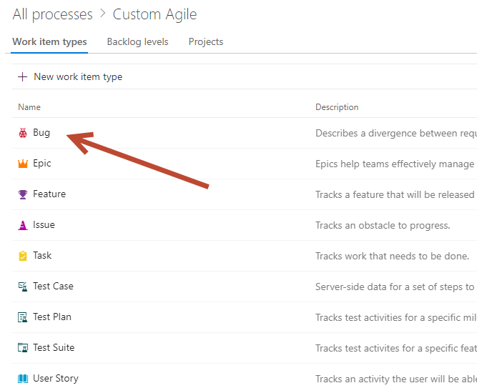

1. Click on New Field:

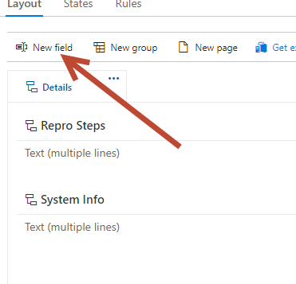

1. You can add an existing field, or create a whole new one. Let’s create a new funny one (you can customize it to anything you like!). Hit Add Field when you are done.

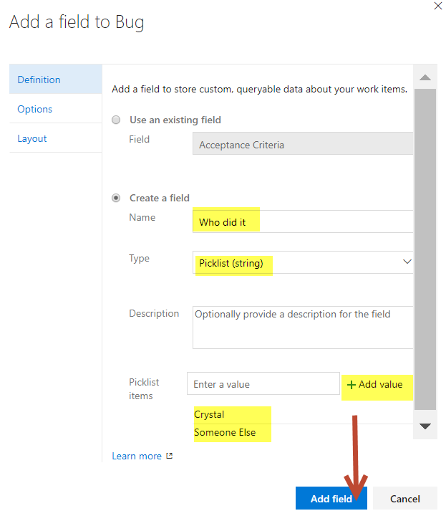

1. You will see your new field has been added:

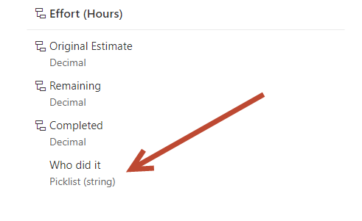

1. Mouseover the Completed option and hit the 3 dots that appear, then select Edit:

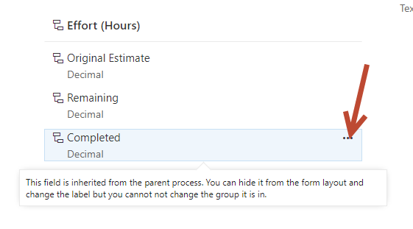

1. Browse the different tabs here, there is a Definition, Options, and Layout tab. Let’s change the Options Tab and make it Required and give it a default value:

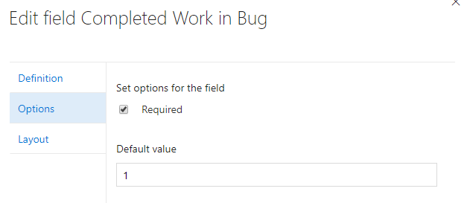

1. Click on States

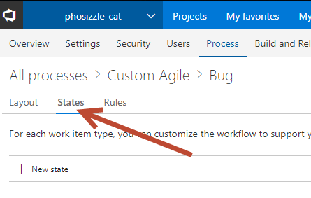

1. Let’s add a New State. We will call it UAT Testing, set it to In Progress and as a custom color. Click Create when you are done.

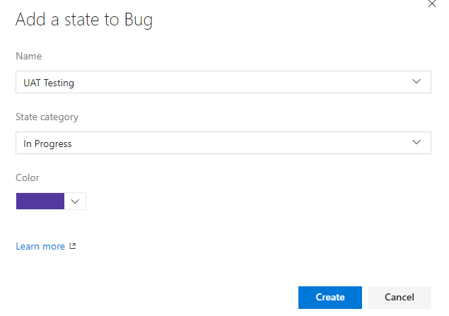

1. Now click on Rules.

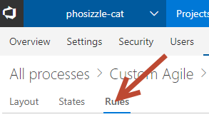

1. Click New Rule. And let’s create one. You can automate ANY behavior here that you want. Here I will utilize the new field I created, so that it says: “If Crystal breaks something, then assign that work item to her”. Click Save. Create an additional rule of your own that you think would be useful!

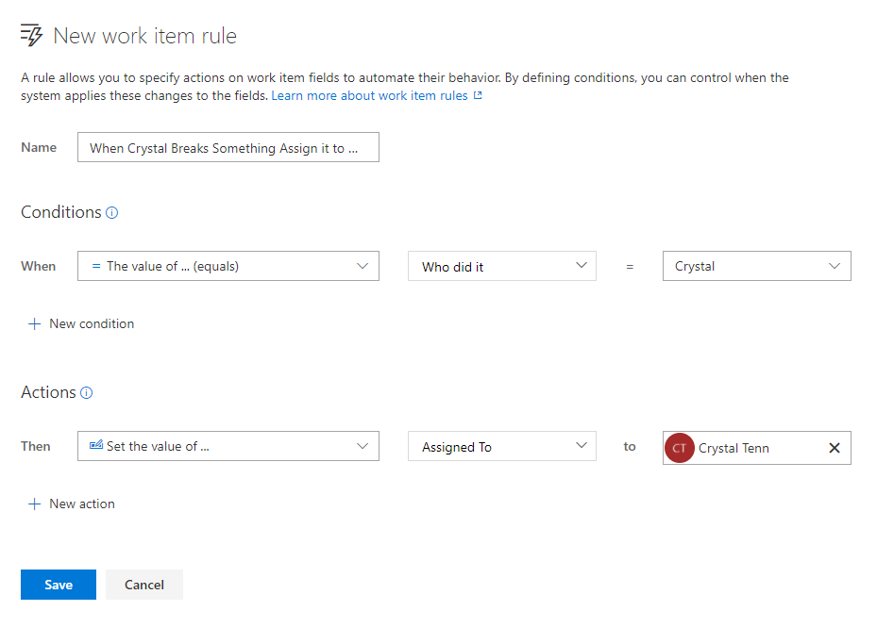

1. While we are in the main project settings, click on the Security tab and check out the default VSTS security groups! We will go over this more in depth later!

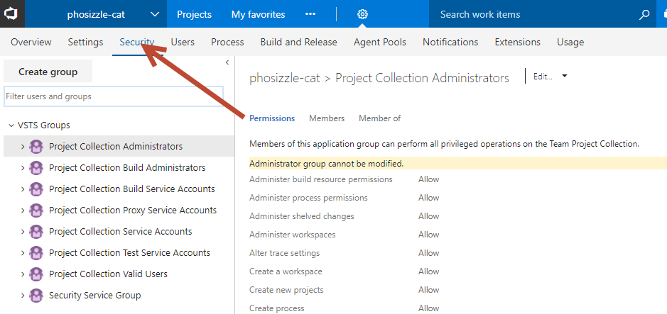

1. Once you have created 2 rules, you are done with this part!

Exercise 3: Setup Your Sprint (15 mins)

Now we will setup sprints for our two Web teams that are using Agile. They both want 3-week sprints starting with TODAY as the first day of the Sprint. You will assign hours to yourself as a team member.

Tasks

1. Setup the Sprints
2. Click on the Pho Sho team. This will manage Project settings **for the team on this project.**

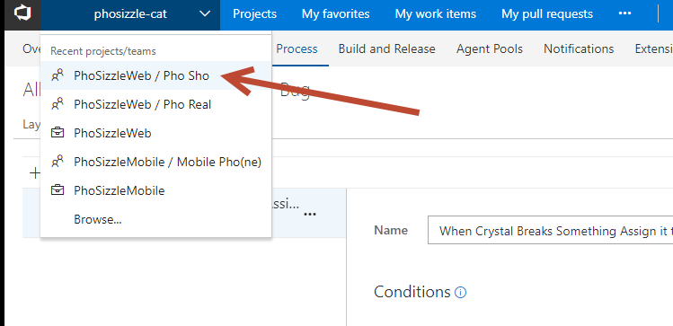

1. Notice the team is PhoSizzleWeb with **TEAM** set to Pho Sho. Click on the Settings Gear, then the Work tab, then Iterations.

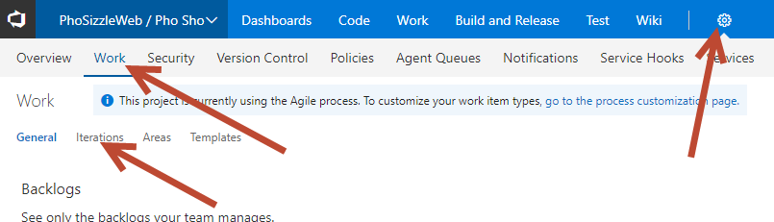

1. Click Select Iteration:

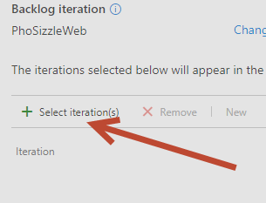

1. Add all 3 Iterations and hit Save and Close.

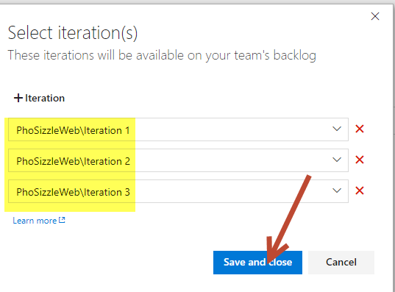

1. Click on The PhoSizzleWeb project with NO TEAM selected, notice where the red arrow is it is just the name of the project (no team name anymore). This will now bring you to the **project settings for ALL teams**. You can add additional Iterations.

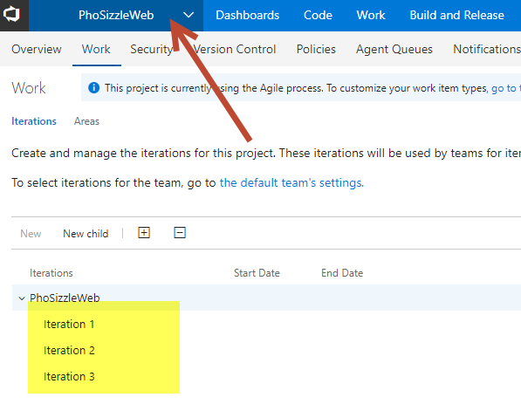

1. You can mouseover one of the Iterations to change its name, edit it, delete it, change security, or set the dates for it.

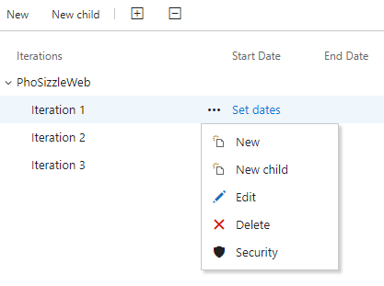

1. Let’s change the name of all of these from “Iteration” to “Sprint” and set the dates for 3-week sprints, starting with today. It should look like this when you are done:

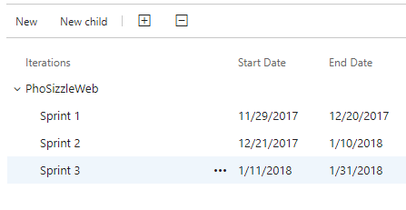

1. Now click on the Pho Real team. Click Settings then Iterations.

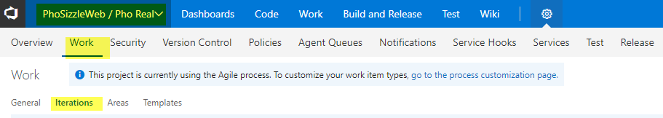

1. Click Select Iterations. Then add all 3 sprints in.

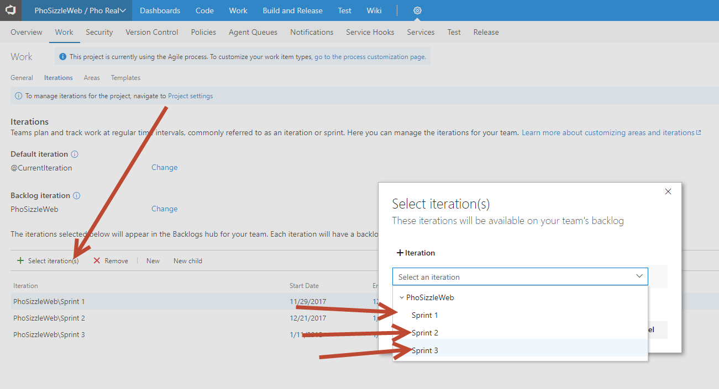

1. Swap to the Pho Sho team, and repeat step 8 and 9 there.
2. Now click on the Pho Real team and click the Work tab to look at the Backlog. You should see your sprints show up on the left, and Current should be set to Sprint 1.

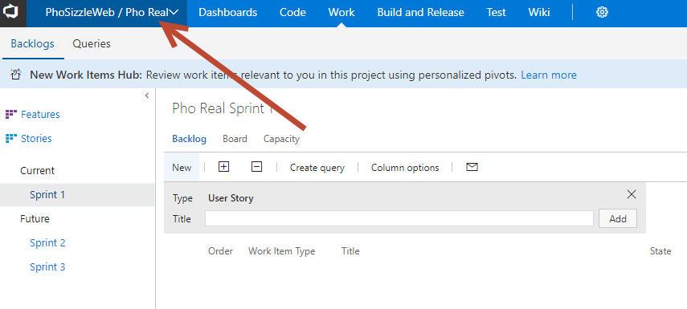

1. Click the Capacity button.

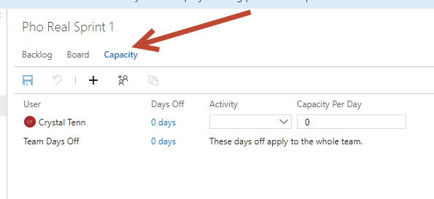

1. Let’s say that you are taking off the first two Friday’s of the sprint.

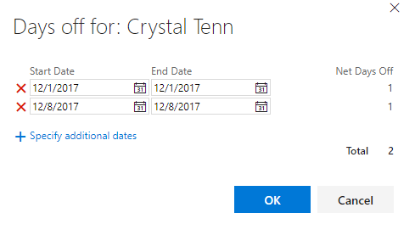

1. Choose any Activity Role you would like, I will choose Development.
2. Let’s say that you want to have a capacity of 6 hours per day of work (this is to realistically assume ~2 hours of meetings / emails / other per day that is not contributing to the sprint. It should look like this now:

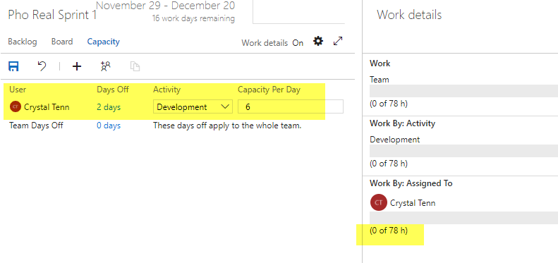

1. You should see your 2 days off. You should also see on the right side, the number of hours that you can be allocated to work on the sprint. These hours will get filled up by the tasks on the board. Typically, devs and QA are allocated on sprints. Usually project managers and BAs are not allocated on the sprint work itself, but they work ahead of the sprint to make new backlog items and to manage VSTS itself.
2. Don’t forget to hit the Save button when you are done!

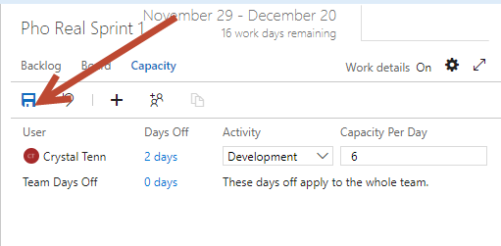

1. Move to the Pho Sho team now. Congrats, you are allocated to two teams! This is entirely possible for someone to be allocated to more than one team, for example sometimes a UI designer will have 3 hours each on two different teams because each team doesn’t have a designer dedicated to them. Since you put 6 hours on the other team, maybe just put 1 hour for yourself on this one. Don’t forget to add your days off and Activity!!! Finally, hit Save.

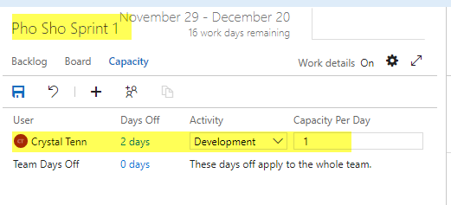

1. For the Mobile Kanban team, we will not need to complete the Sprint setup since they are using Kanban. You are done with Exercise 3.

Exercise 4: Populate Your Sprint (40 mins)

Now we will setup sprints actual backlog items for our teams.

* The Pho Sho team wants to use VSTS itself on the web to add backlog items.
* The Pho Real team wants to use Excel to bulk edit work items easily.
* The Mobile Pho(ne) team wants to use whichever one you like to use better.

I will walk you through how to help the Pho Sho and Pho Real team use VSTS and Excel. Then you can help the Mobile Phone team on your own using either process. You can toggle whether to use Epics/Features/Stories in the Settings gear and hit the Backlogs tab.

*Let me explain the different type of Work Items.*

* ***Epics*** *– captures a large body of work. It is essentially a large user story that can be broken down into many smaller stories. It may take several sprints to complete an epic. An epic can span more than one project if multiple projects are included in the board to which the epic belongs.* 
  + *The relationship between epics and features is the most controversial in the agile community. In my opinion, an epic is a broader concept and an epic can be broken down into different features.*
* ***Features*** *- is a distinct element of functionality which can provide capabilities to the business. It generally takes many iterations to deliver a feature. A user story is a part of the feature. By splitting a feature in smaller stories, the user can give early feedback to the developers to issues quickly.*
* ***User Story*** *- simply something a user wants. User stories are more than just text written on an index card but for our purposes here, just think of user story as a bit of text saying something like, "Paginate the monthly sales report" or, "Change tax calculations on invoices." Many teams have learned the benefits of writing user stories in the form of: "As a <type of user> I <want/can/am able to/need to/etc.> so that <some reason>."*

Tasks

1. Adding Backlog Items in VSTS and Using Templates + Tagging
2. Click on the Pho Sho Team and go to the Backlog page.

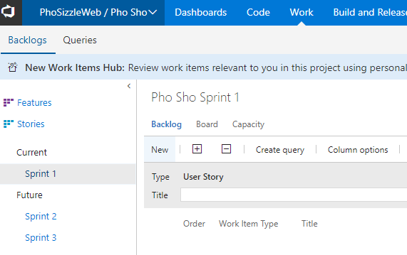

1. Let’s create one sample template. Add a User Story for “Create Specials Menu” and hit Add.

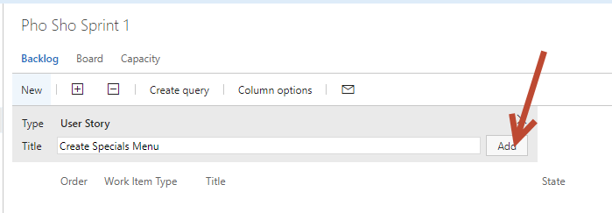

1. Click on the text of your new User Story to edit it:

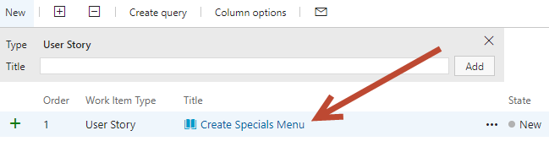

1. Match the user story to the following screenshot, explanations of each numbered section are below the screenshot:

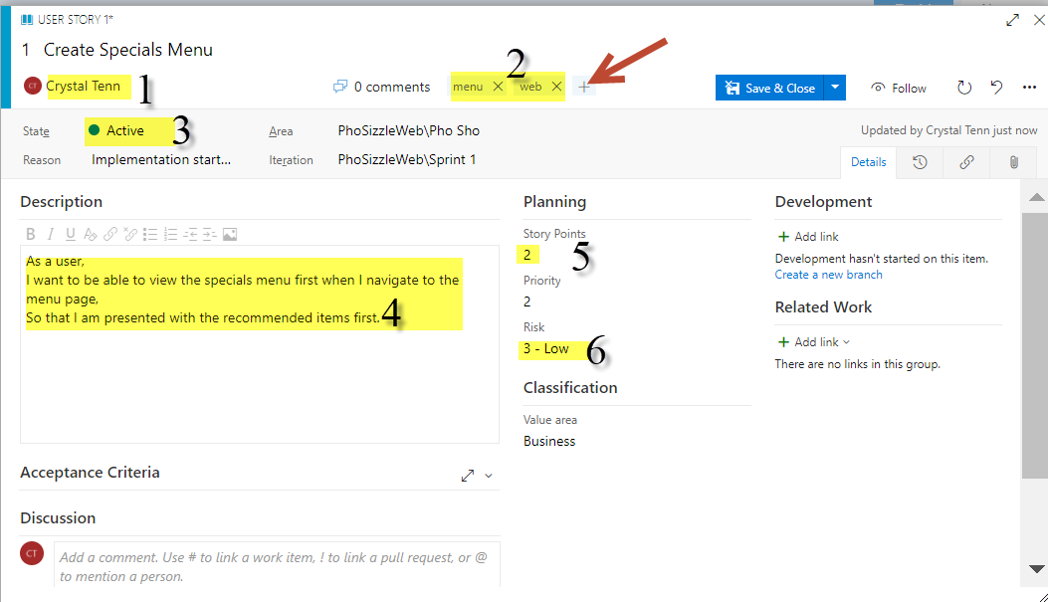

Screnshot explanations:

1. Click on the dropdown to assign the user story to a user, assign it to yourself.
2. Add two tags to the user story by clicking the “+” sign where the red arrow is. Add a tag for “menu” and “web”.
3. Change the state to Active.
4. Add a description.
5. Add story points
6. Add a risk level.
7. Once you have added all of those, Save it by clicking on the little arrow and hitting Save on the dropdown as shown below:

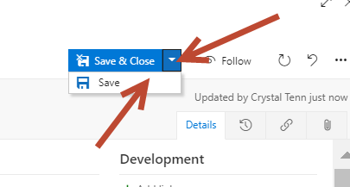

1. On the right top of the same user story, click on the “…” icon. Choose Templates > Capture.

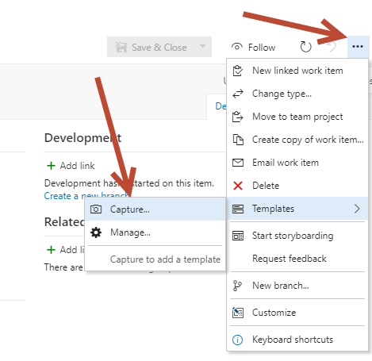

1. You can choose which parts of your user story that you want to be in the template and you can edit parts also. Here you can just use the default and **hit save first, then hit copy link.**

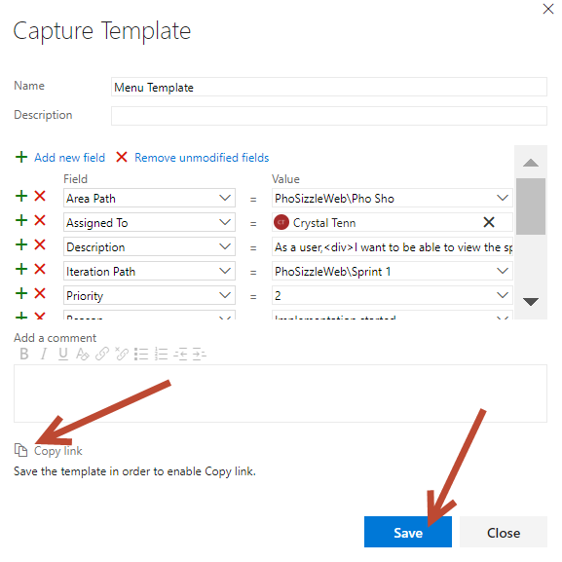

1. Close the modal from the above screenshot.
2. Close the work item.
3. Paste your URL that you copied from step 7 into your browser and navigate to it.



1. You will land on a page like below. You may need to change the State if you get an error.

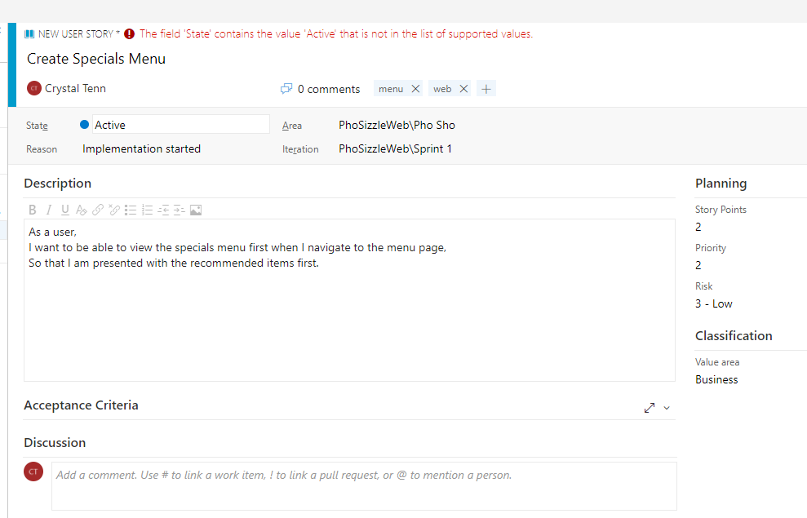

1. Change the text “Special” to “Dessert” and Save this work item.
2. If you need to get back to your Templates that you saved, click on the Setting Gear > Work > User Story > Templates and you will see a page like this. You can get your templates URL again or edit the templates from here.   
   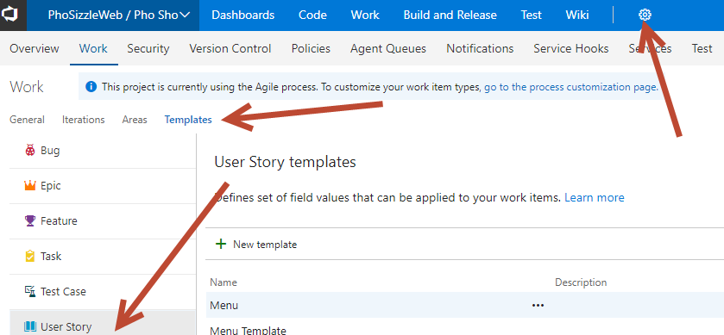
3. Grab the URL again if you need it by clicking the 3 dots next to the template you made and selecting “Copy Link”.

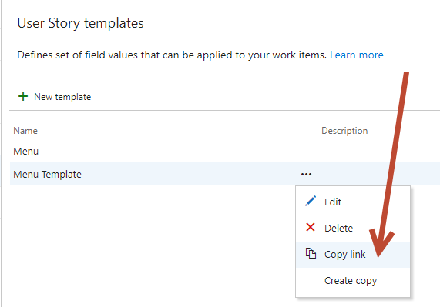

1. You have two work items now, a Specials and Dessert one. Make 3 more work items the same except change it to menu for: Appetizers, Lunch, and Dinner. You should see the following on your Backlog page when you are done:

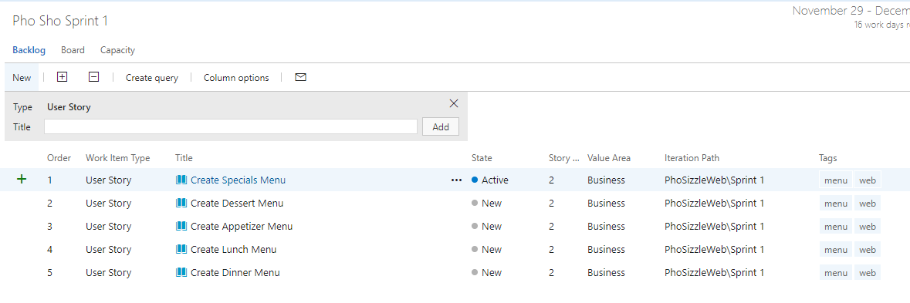

1. Create an additional User Story called “Low calorie tag”. Click Add.

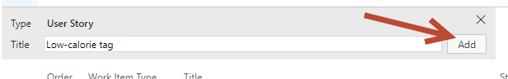

1. Add the highlighted below to your user story. Then click on Add Link with the red arrow in the screenshot below:

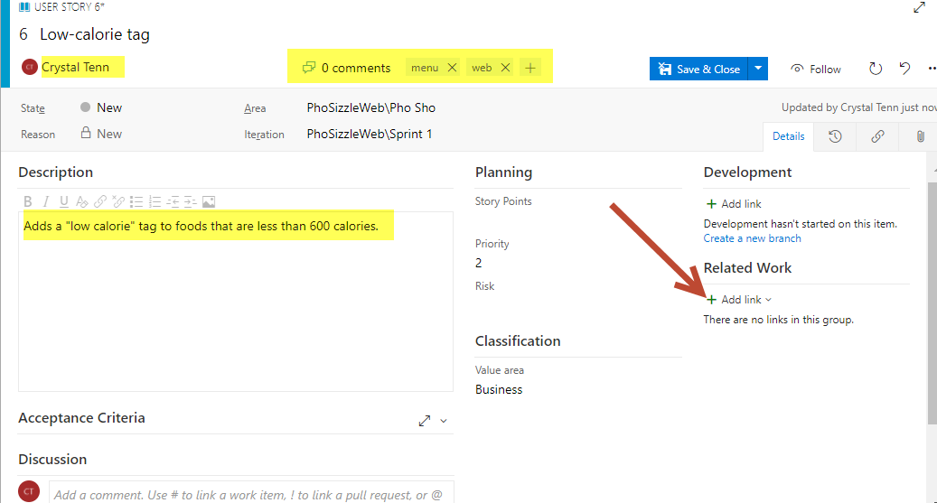

1. Choose Parent and fill in the work item number to link it to. In this example it is work item 1. Click OK.

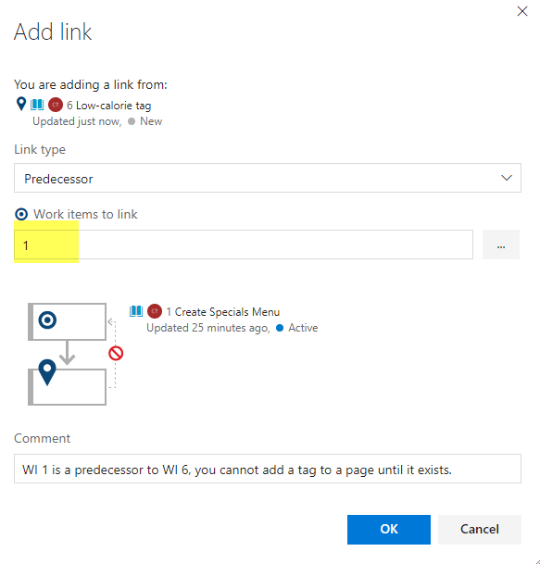

*Note: All of the links and their definitions are found on the documentation here:* [*https://msdn.microsoft.com/en-us/library/dd293534.aspx*](https://msdn.microsoft.com/en-us/library/dd293534.aspx)

*Please take a moment to view the page linked above.*

1. Add all 5 of the menu items as predecessors. All of these need to be completed before you can add the “low calorie tag” to that particular page. Your Links should look like this when you are done.

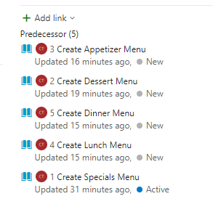

1. Adding Backlog Items using Bulk Edit in Excel + Tagging
2. Click on the Pho Real team and go to their Backlog. It should be empty, as their team has a separate backlog from the Pho Sho team’s (that you just edited).

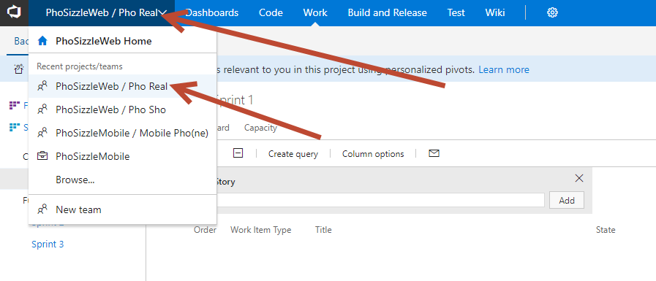

*When you have a lot of work items to add or modify, using Excel can save you time. Use a flat list to bulk add or modify several types of work items at once, such as backlog items, tasks, bugs, or issues. Use a tree list to bulk add or modify work items and their parent-child links. Make sure you either have the TFS office integrator or any version of Visual Studio over 2010 installed on the computer.*

1. Open Excel. Click on the Team tab. If you don’t have that, you might need to re-enable it: <https://msdn.microsoft.com/library/ms268871.aspx>
2. Under the Team tab, click the New List.

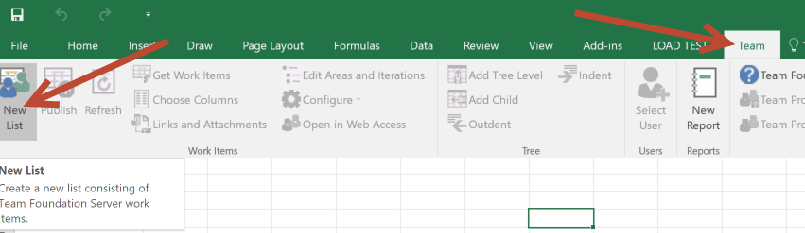

1. Click Servers. Click Add. Connect to the main URL of your project, in this case mine is: <https://phosizzle-cat.visualstudio.com/>

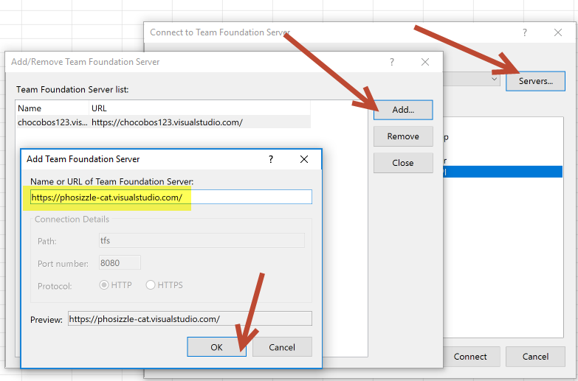

1. Click OK. You will probably need to login to your account.
2. Choose the specific project you are using, you want to select the Web project here like this and click Connect:

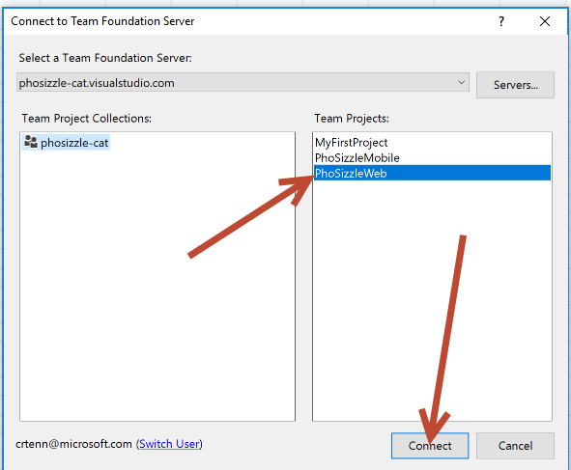

1. Choose Input List on the new Modal popup.

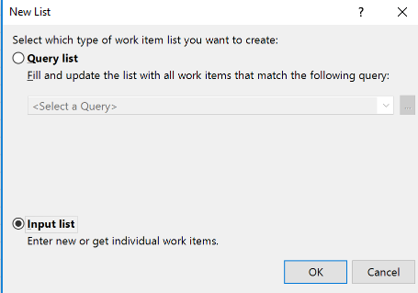

1. Add items to your Excel, click the dropdown to see choices. You can skip the ID, this will be populated for you automatically. There is a dropdown of options for some columns. Note ID is readonly, that will get populated for you.

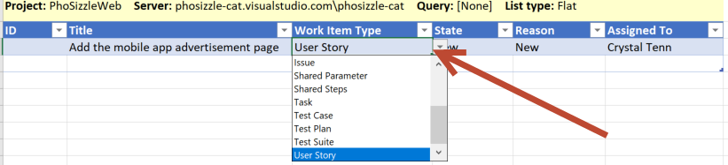

1. You should add 5 or so items. You can copy paste a whole row if you like or drag the blue arrow on the bottom right to make more rows. It will look like this when you are done:

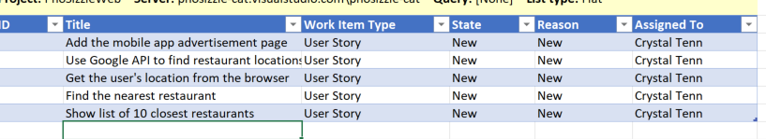

1. **You must select a box INSIDE of the grid in order to publish, make sure you are not selecting OUTSIDE of the grid. The screenshot above is an example of selecting OUTSIDE of the grid of work items, don’t do that!**
2. Click Teams, then Publish. This will publish the work items to the main PhoSizzleWeb project, not the specific team. Now we will bulk modify moving all of these work items to our team project.

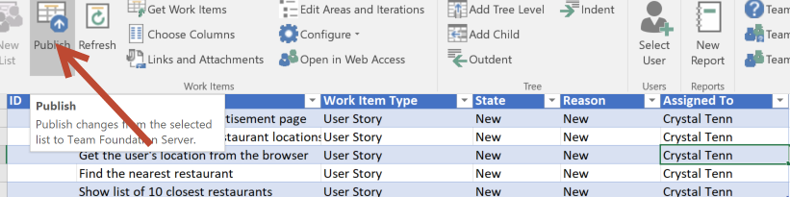

* 1. *Note: You can keep work items / user stories in the backlog of a specific team or for the whole project and move them as needed. Sometimes you do not know which team will handle some work items and it should go into the general project backlog.*
  2. *If you want to specify exactly where to get the items from and where to put them, you can do a Query. And in step 7 you would use Query list instead of Input List.*

1. Go to your general PhoSizzleWeb project, with NO TEAM SELECTED. Click on Stories on the left, they were not added to a specific sprint. They are just in the backlog. You will see them here:

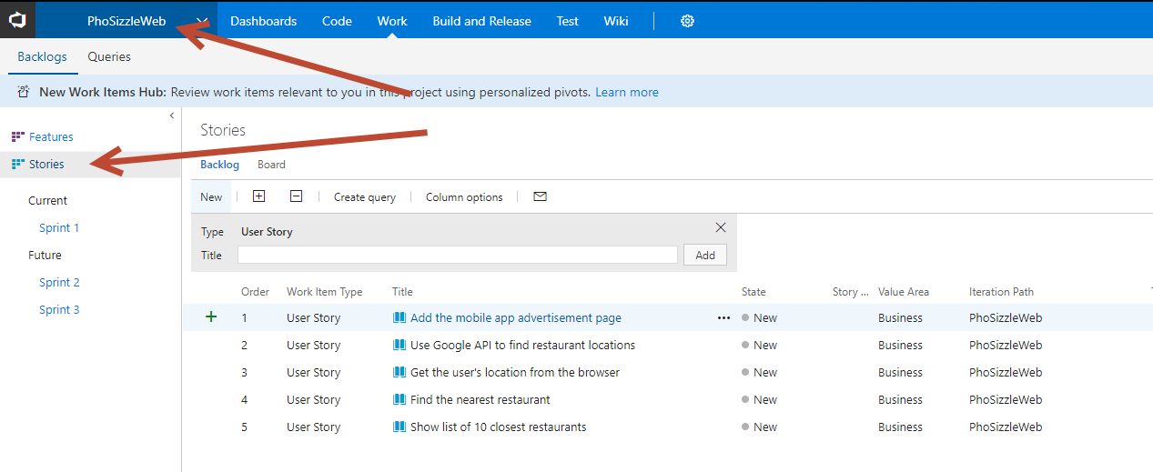

1. Select all of these user stories by clicking on a part of the User Story away from the hyperlink, like to the side where it says Work Item Type (see a good spot to click on highlighted in yellow in the screenshot below)… Hold Shift, click on the first user story, keep holding shift, click on the last user story, then let go of shift. It should be very lightly highlighted. You will know you got all of them if you see all of the “…” displaying for each user story.

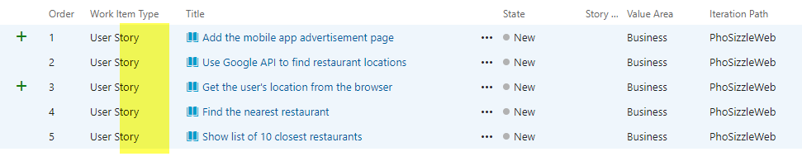

1. On any one of the selected ones, click Edit.

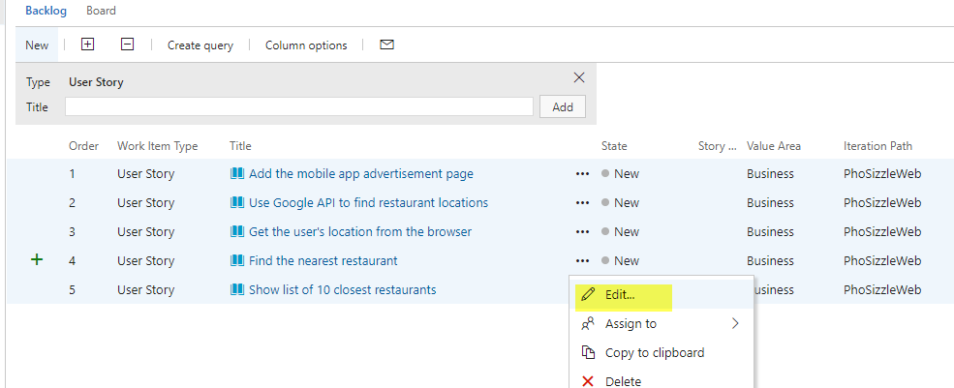

1. Choose Area Path to be Pho Real and Iteration Path to be Sprint 1:

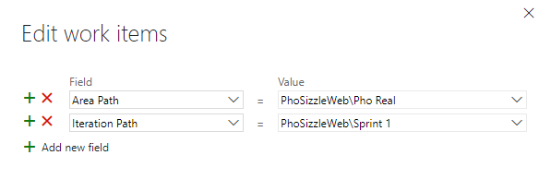

1. Click Save.
2. Go to your Pho Real Sprint 1:

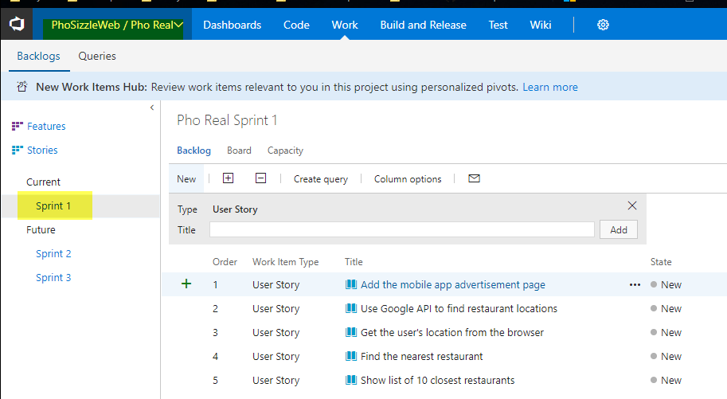

1. Let’s say you wanted to do this directly in Excel. The main reason for putting it into the main project is to give a choice if you aren’t sure which team—and to practice bulk Editing in VSTS on the website to move items around.
2. Go back to your same sheet in Excel. Under the Teams tab, click Choose Columns.

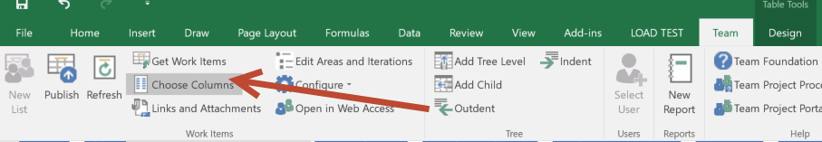

1. Find Area Path and Iteration Path, move them to the right column. Hit OK.

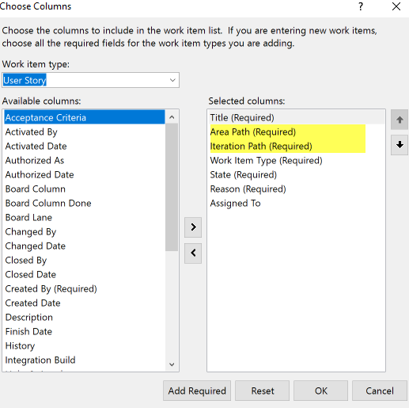

1. In the Team tab, hit the Refresh button. Then it will be greyed out and you will see your Area Path and Iteration Path.

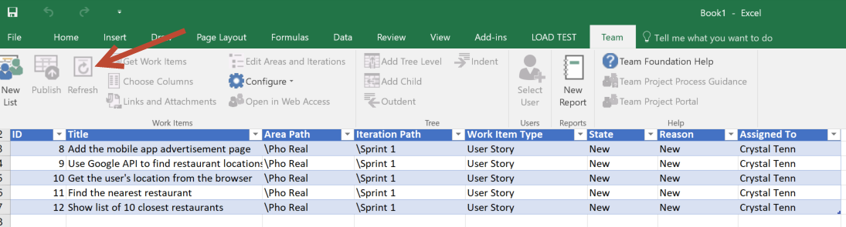

1. Add two more entries by copy pasting a row into the row below. Change the text to be different.
2. Based on the instructions given before, try adding the Tags column.
3. Add tags to your user stories.
4. Your final sheet should look like the following (note the actual content doesn’t matter):

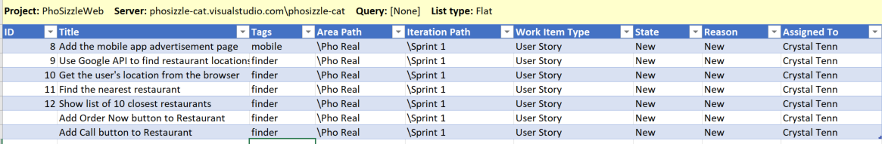

1. Make sure that your selector is INSIDE of the actual table.
2. Select the Teams tab. Hit Publish.
3. Go back to VSTS and you should see your new User Stories appear in the right Team and Iteration:

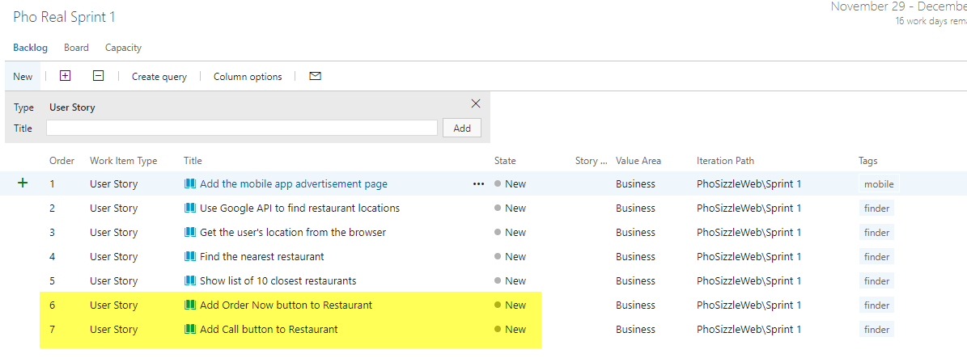

1. You should see tags on all of your User Stories, for example:

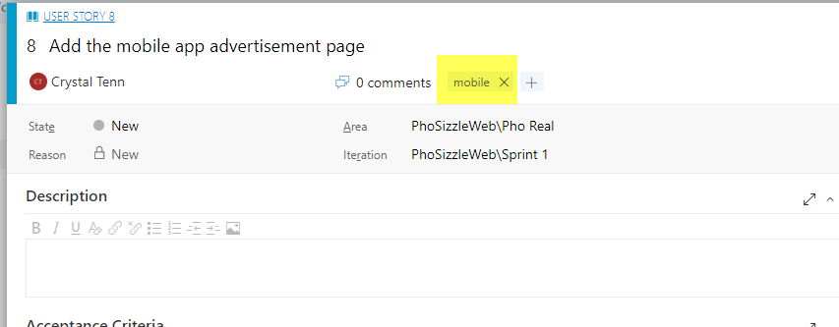

1. Adding Backlog Items in VSTS
2. Click on the Mobile Pho(ne) project. Create the following 5 work items using either VSTS or the Excel Bulk edit process. Just do the title, don’t worry about description / other boxes for now since this is just an example.

Exercise 5: Setup Your Board (20 mins)

The work items on the board are called Cards.

The Pho Real team wants the following customizations to their board:

* They want the ID to show on the Task card.
* They want the work item type and created date to be shown on the Task card.
* They want all cards with the tag Mobile to be Red.

The Pho Sho team isn’t really picky and doesn’t want anything customized.

I will show you the difference of the Kanban Board for the The Mobile Pho(ne) team and how to setup their board. The Mobile Pho(ne) team wants the following customizations:

* They want 2 additional columns: With Impediments and UAT Testing.
* They want a Swimlane for Expedite
* They want anything tagged mobile to be have the tag color be yellow

Tasks

1. Setup the Sprint Board for the Pho Real Team
2. Click on the Pho Real team. Go to Work and Board.
3. Click on the settings gear on the board.

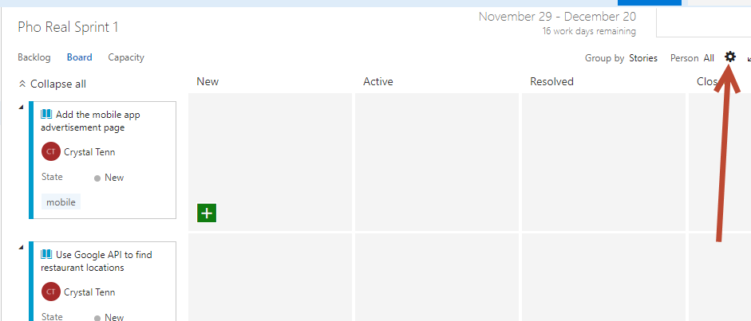

1. In the Fields Tab on the left.. Check the box for Show ID. Click on Additional Fields +Field and add the Work Item Type and Create Date.

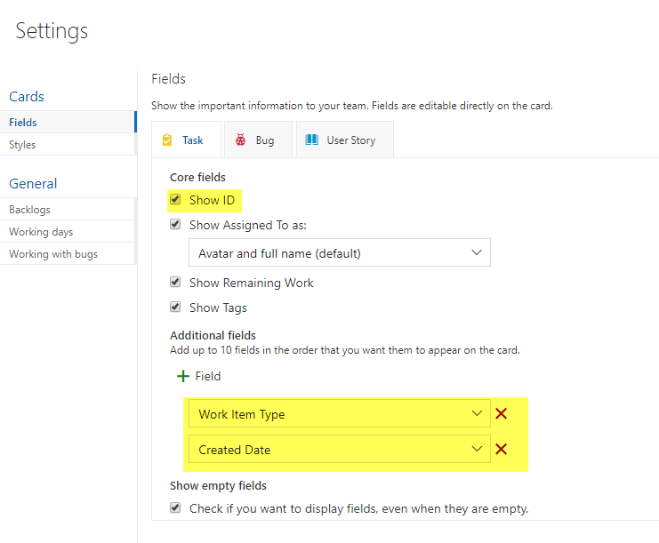

1. Click on the Styles Tab, add a new Style Rule called “Menu Red” and choose the color and make it so Tags Contains Mobile. Or, some other tag that is on your board if you varied the names and tags.

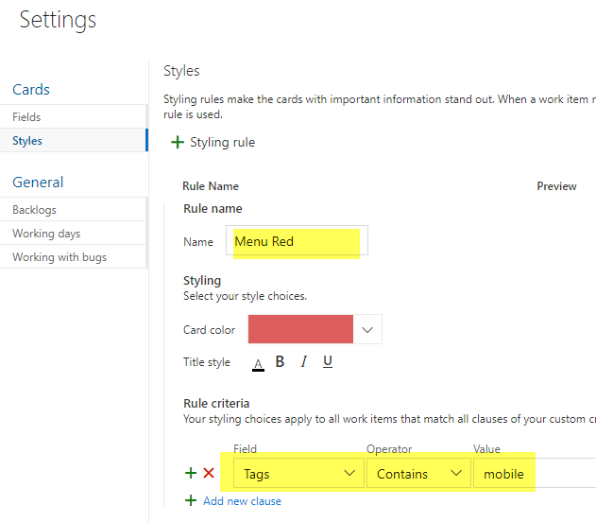

1. You should see the styling rule show up:

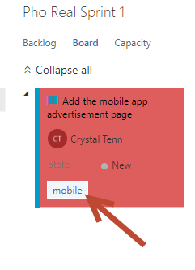

1. Click New Item to add a Task.

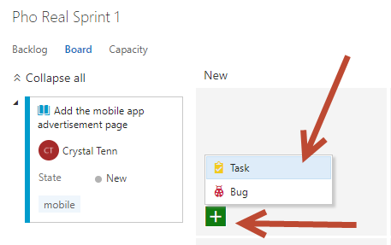

1. Add the following 3 tasks (if you hit enter after each task, it will automatically go to the next new task. Note the developers usually will “task out” each item on their own at the beginning of a sprint once the user story items have been assigned. It is not up to the BA or project manager to know the tasks, the tasks can often be very technical in nature):

* Create the advertisement page
* Add link on the homepage to “Check out our new mobile app” and link to new page
* Add wireframe for new page

1. Your tasks should look like the following:

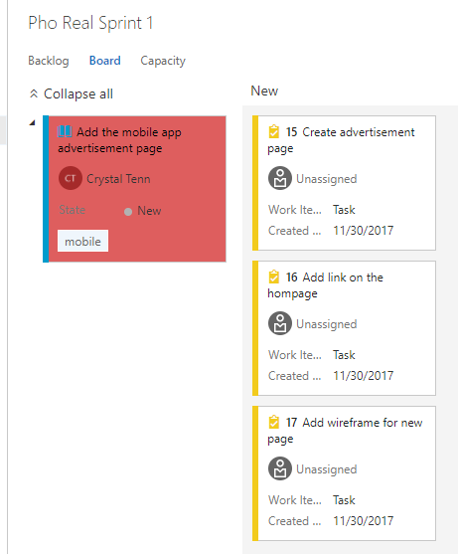

1. Click on the “Unassigned” text and use the dropdown to add yourself to all 3 tasks.

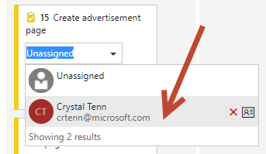

1. Add 5 hours of work to each item:

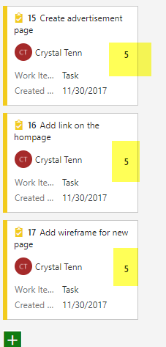

1. Click on Capacity to see the hours have added to your name and to the team.

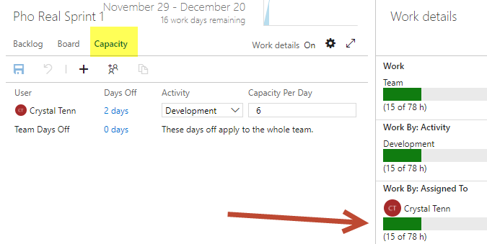

1. Click on the Burndown chart to see the total hours for the sprint so far.

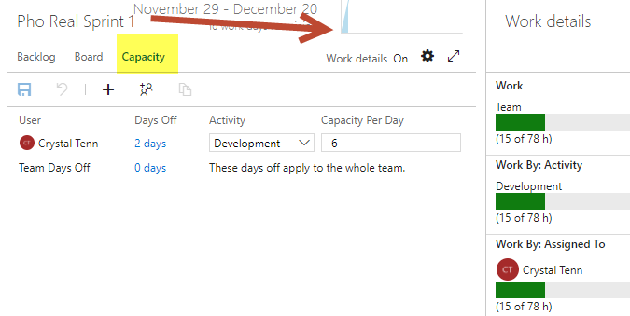

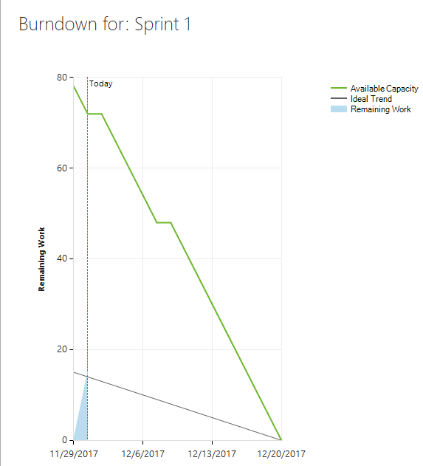

1. Move one task to the Active column. You will see the total hours per column displayed above the board:

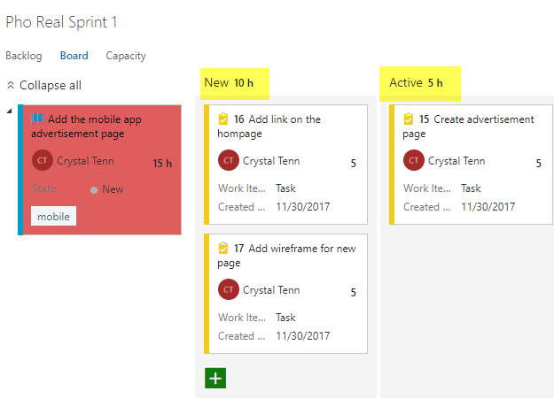

1. **Setup the Kanban Board for the Mobile Pho(ne) Team**
2. Navigate to the Mobile Pho(ne) Team board.
   1. Note: Kanban does not have sprints, an end, or a time limit. It is a continuous workflow like a big team to-do list. A project has a board that lives as long as the project. As new work is needed, it is added to the to do side and prioritized with a color. This should be used for slower moving projects, smaller ones, ones without a specific team, etc.
      1. Limited work should be in progress at one time.
      2. Once work is completed it is moved to the done side.
      3. There is no time limit or specific lifecycle. Work is completed based on priority and as team members get capacity.

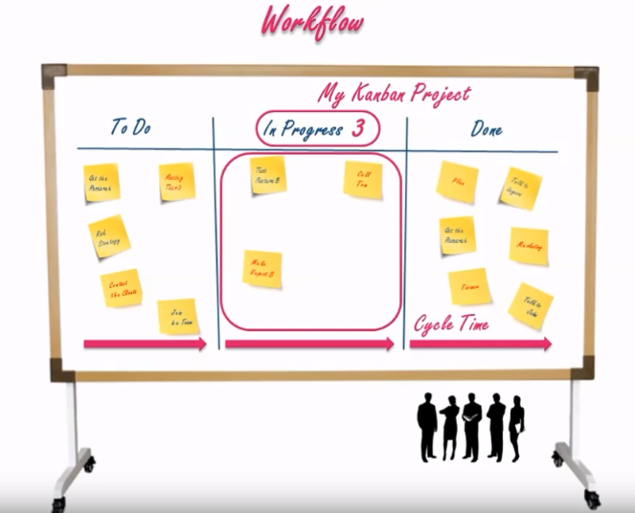

1. Your team board should look like this, it’s different from the sprint board (note you should have 5 or so stories on the board from the previous exercise where you added stories):

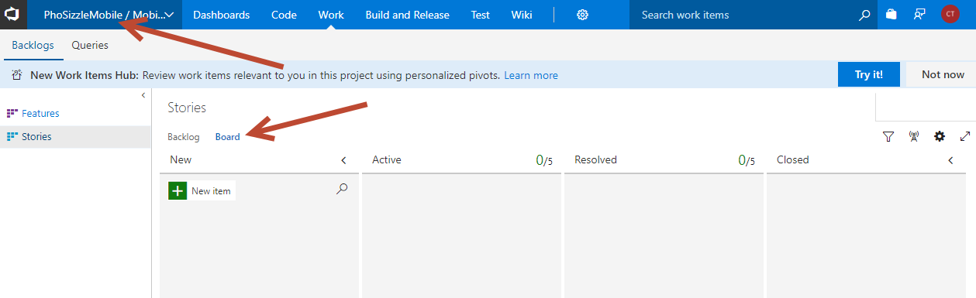

1. Remember the requirements they asked for? Let’s find a way to add the following:
   1. They want 2 additional columns: With Impediments and UAT Testing.
   2. They want a Swimlane for Expedite
   3. They want anything tagged mobile to be have the tag color be yellow
2. Click on the settings gear on the board.

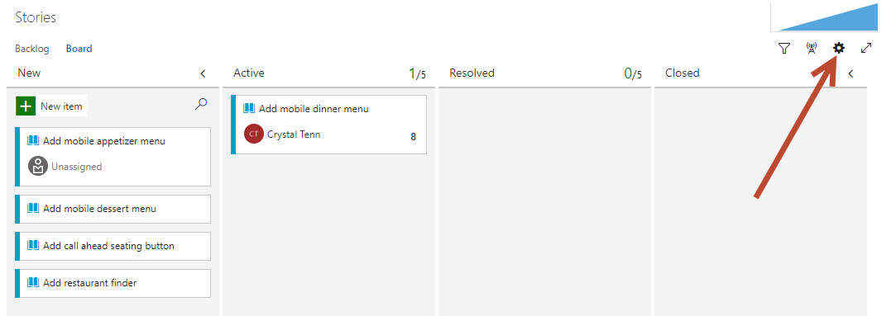

1. In the Columns Tab, click + Column. Add both Impediments and UAT Testing. Then drag and drop the columns so they are in the same order as the screenshot below:

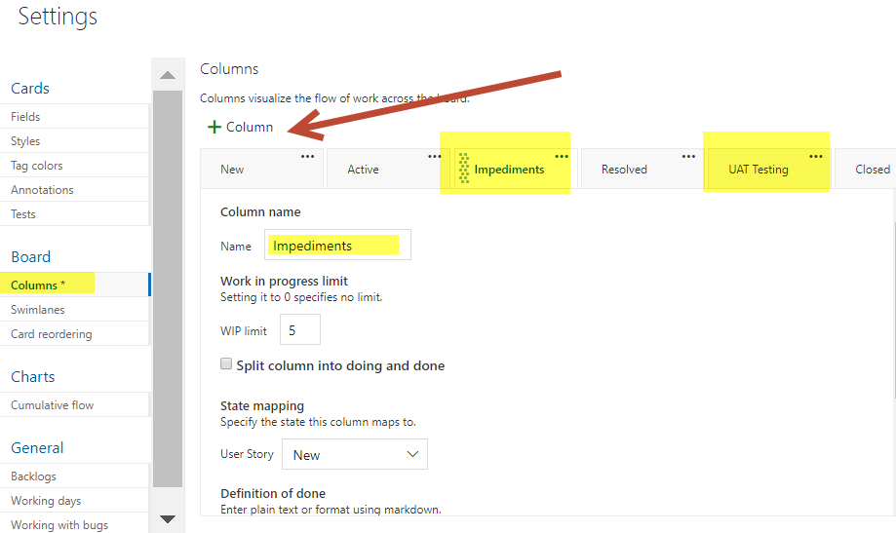

1. Go to the Swimlanes tab and hit + Swimlane and name it Expedite.

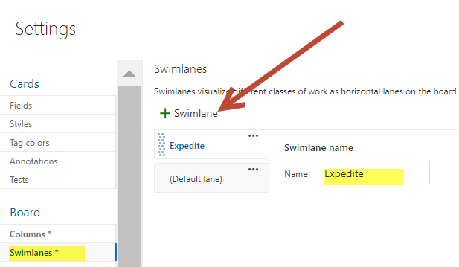

1. Click on the Tag Color tab and add one for the mobile, if you don’t have a mobile tag yet you will need to type it in. Hit Save when you are done with this change (or you can go through other settings to see what else is customizable).

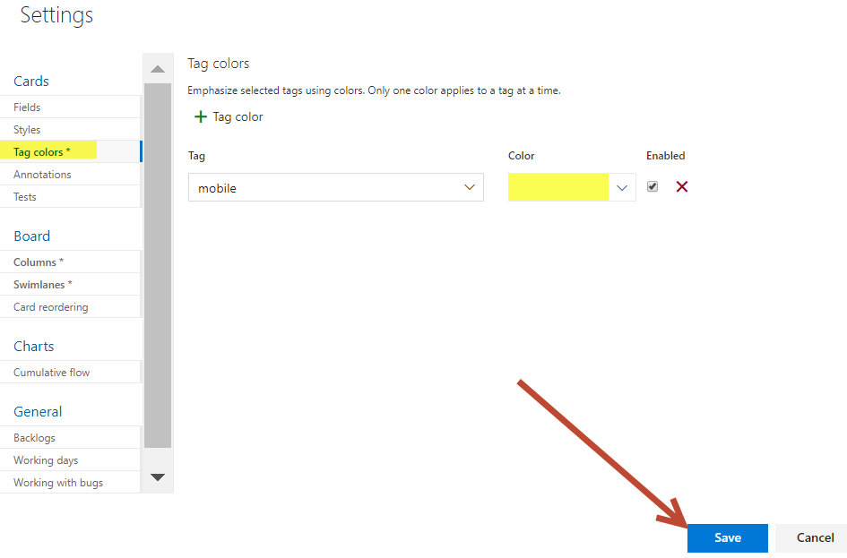

1. The purpose of the Swimlane is to bring up a horizontal row of items that need to be at the top of the board, or sorted into a column in the board. Drag a work item into the Expedite swim lane.

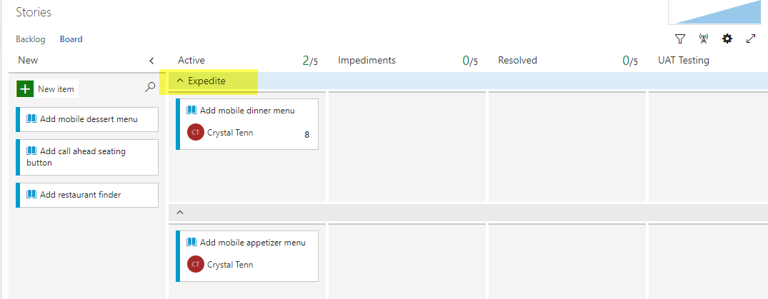

**Exercise 6: Logging Bugs, Searching Work Items, Discussions, Attachments (15 mins)**

The Pho Real team wants the following bug added to their current Sprint:

They also want you to add a Discussion note on bug and more details. They want an attachment added to the bug to show proof the website broke.

You are the developer working on the project and you forgot the work item ID for the user story related to “” and you need to find it. You will learn how to search for the work item.

**Tasks**

1. Logging bugs with attachments
2. Click on the Pho Real team. Go to Work and Board. Click to create a new Work Item on the green “+” button shown below:

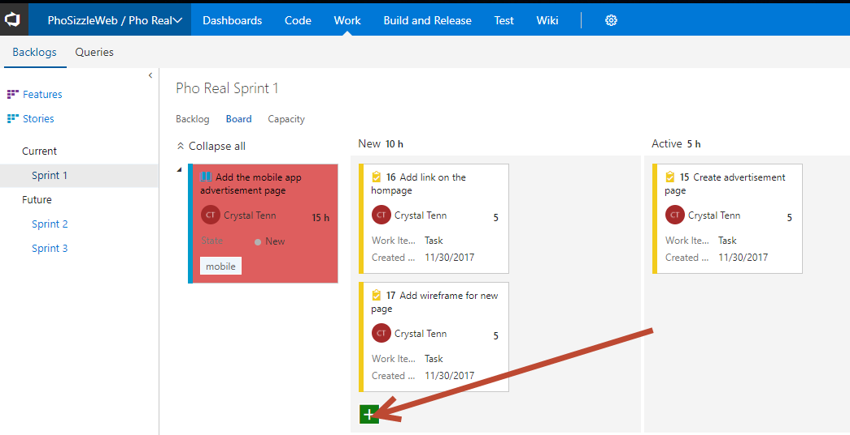

1. Choose Bug

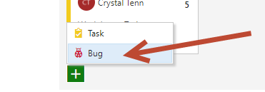

1. Add the following text: Font size should be 11 and font should be Calibri

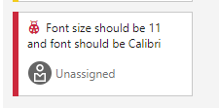

1. Click on the bug you just created. Click on the paperclip icon on the right:

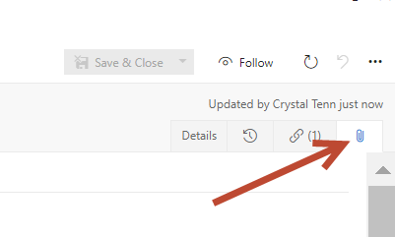

1. Attach a random image file. Once it is attached you can double click on the image to be able to see it in the VSTS web browser:

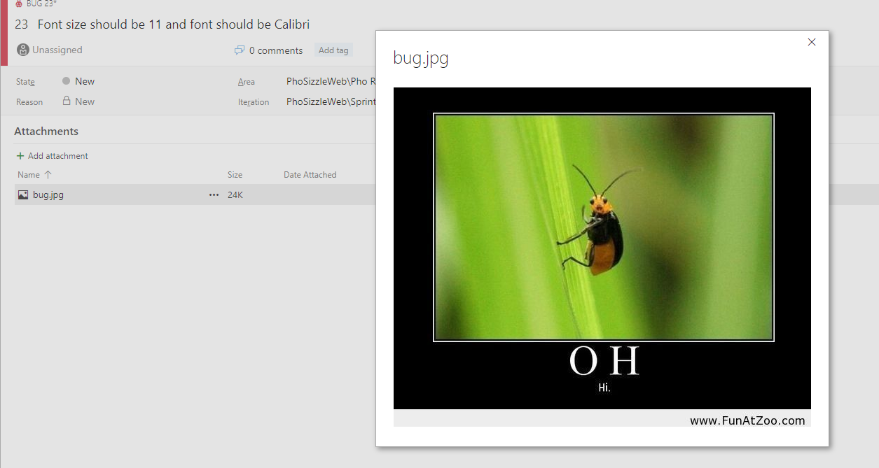

1. Click on the Details tab again. Add Repro steps.

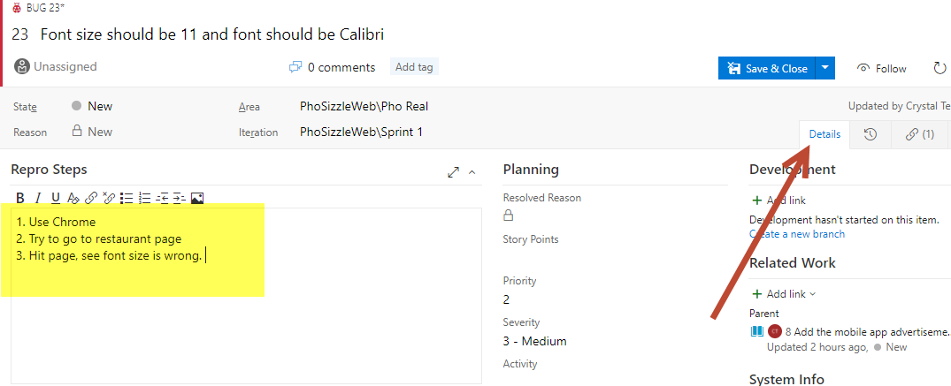

1. Add text to the discussion, and hit Save (hit the arrow on the Save and Close to Save without closing). Once you hit Save, your comment will show up in the Discussion area:

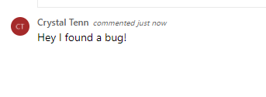

1. Searching Work Items
2. So, let’s say you forgot the ID of your work item. You know it has to do with the Google API. On the top right where it says “Search work items” type in: Google API.

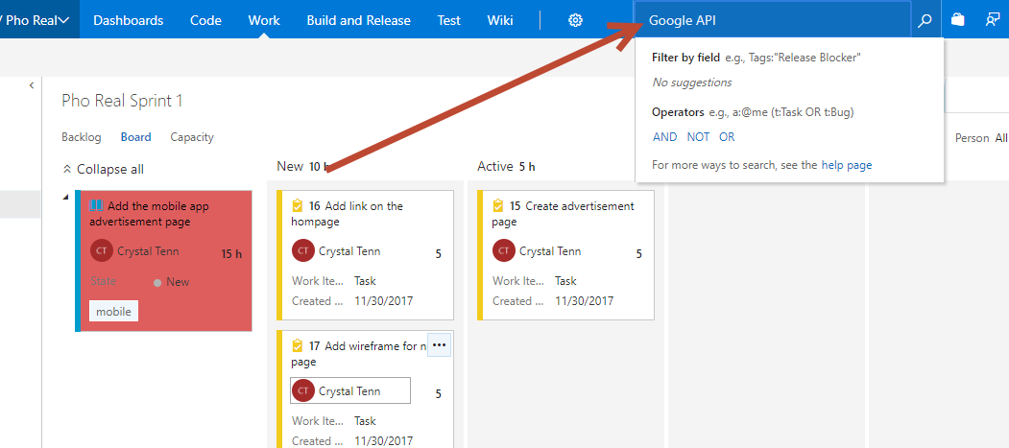

1. As a note, you might get a “Indexing your account data” which occurs with a new account. You may need to do wait 2-5 mins. Then, you will see a page like this:

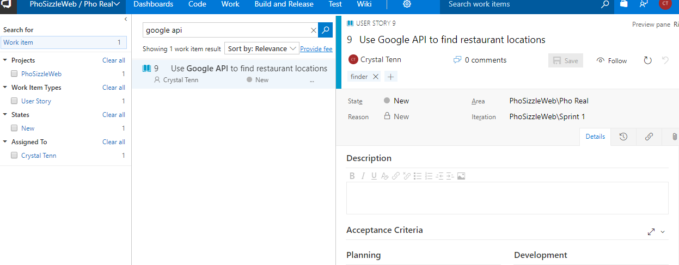

1. Try testing out other search terms! Then you are done with this exercise.

Exercise 7: Create Effective Queries (15 mins)

“Pho Real” is a *real* demanding team, and they want more customization. They want the following queries to be created for them:

* Current # Incomplete Tasks in the current sprint
* Current Priority 1 and 2 Tasks in the current sprint
* Current # of Incomplete tasks in the current sprint, assigned to you

They also want to know what is in the existing queries.

* Bug Triage
* Resolved Bugs

We will find out this information for them. Then they want you to be creative and come up with 2 useful queries that you think they could use and then implement them!

Tasks

1. Create Queries, Read Existing Queries, then make up your own!
2. Go to the Pho Real project Work tab, then hit Queries on the top left:

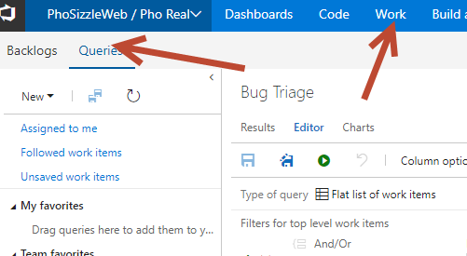

1. Right click Current Iteration, and choose New Query.

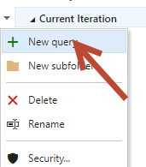

1. Call the New query: Incomplete Tasks. Click OK.

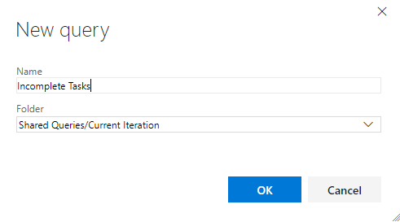

1. Add the following:

* Work Item Type = Any
* And State <> Closed
* And Area Path = Pho Real
* And Iteration Path = @CurrentIteration

Then hit the green run button. The ‘<>’ means ‘does not equal. This query is saying that I want all Pho Real items in the current sprint, of any work item type, that is NOT closed (hence is open). When you run the query you should see all your work items. To test out your query, open another tab, go to the board, move a work item to completed, run the query again, and make sure it doesn’t show up when you hit run.

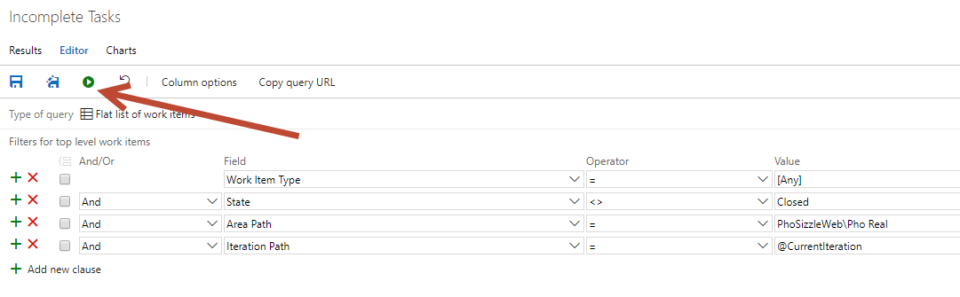

1. Click the Save button and it should be greyed out like the screenshot below:

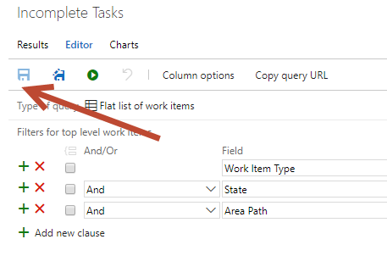

1. Create another new query in the current iteration called “High Priority”.

Add the following:

* Work Item Type = Any
* And Priority = 1
* Or Priority = 2
* And Iteration Path = @CurrentIteration

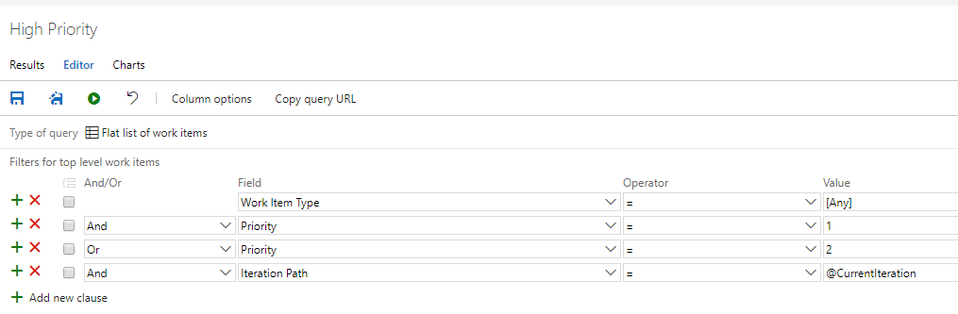

1. Hit Save on this Query.
2. Click on the Incomplete Tasks Query you made. We are going to build off this one and add one more parameter to it, then make it into a new custom Query.
3. Add an additional field for: And Assigned to (Your Name). Hit the **Save as** button which is shown in the screenshot below with the red arrow near the top.

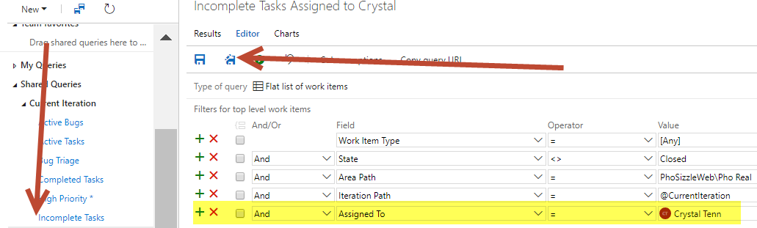

1. Name this new Query. Hit OK.

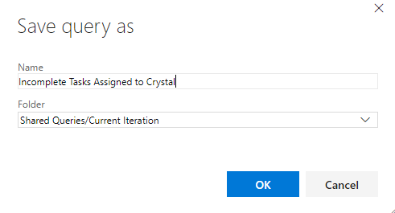

1. Now you have created the 3 queries the team asked for! If you wanted to extend it to different projects, there is a checkbox here:

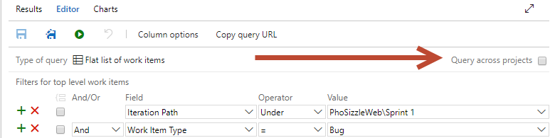

1. Click on the Bug Triage Query to see what is in it. Write a sentence below to describe in English what the Query does:

**Query Explanation**:

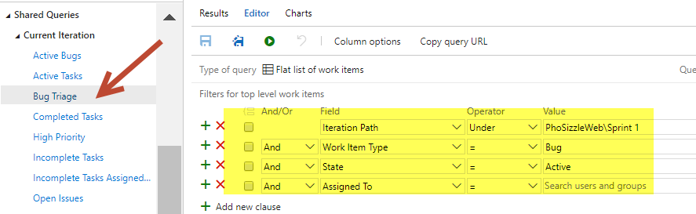

1. Click on the Resolved Bugs Query and see what is in it. Write a sentence below to describe in English what the Query does:

**Query Explanation**:

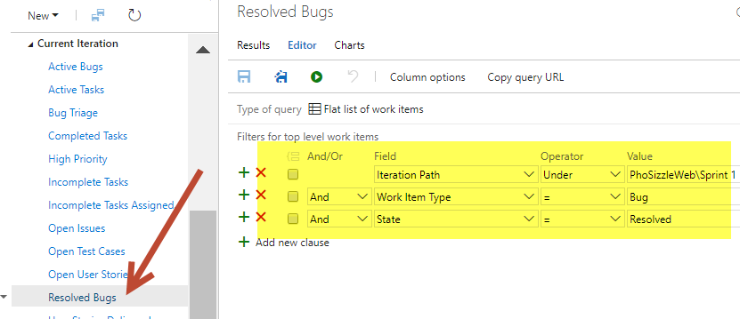

1. Think about your own project and of 2 queries might be useful to you. Create both of these queries. They can be personal or team queries. Make personal queries under the “My Queries” instead of doing it under “Current Iteration”.

**Exercise 8: Monitor Your Work + Team Communication (20 mins)**

The Pho Real team wants to customize their experience and make it easy to onboard new team members. They want you to feel good about finding your items by watching and favoriting, so you can see them on your personal page. And they want a delivery plan. They have created the following objectives for you to complete in this exercise:

* They want to utilize all their cool new queries by adding widgets to a Dashboard.
* They also want a Wiki with 2 pages: General info and Onboarding.
* They want you to favorite 2 work items.
* They want you to add a Watch to 3 work items.
* They want you to create a Delivery Plan to synchronize work between all 3 teams.

**Tasks**

**1. Creating Dashboards and Widgets Utilizing your Queries**

1. Make sure you have the Pho Real team selected. Click on Dashboards.

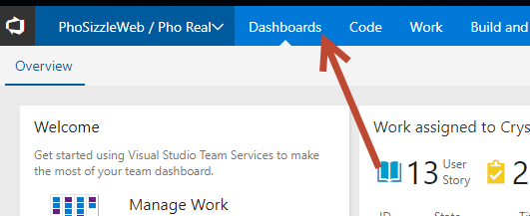

1. Let’s create a New Dashboard. Click the + New button on the top right.

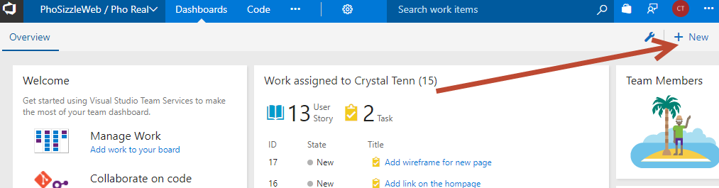

1. Call it Project Management.
2. Hit OK.
3. It will ask you to add a widget on the next page. Choose the “Chart for Work Items”.   
   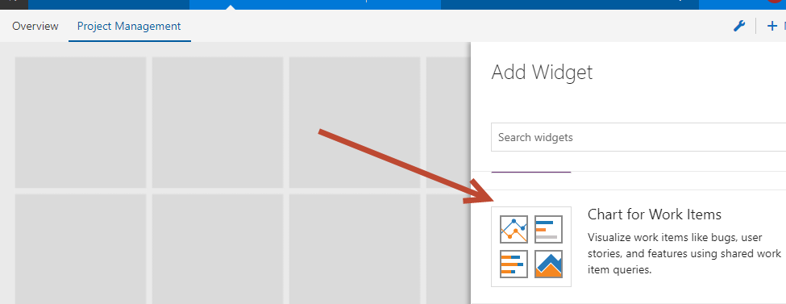
4. Click Add. Click Close on the Add Widget right modal.

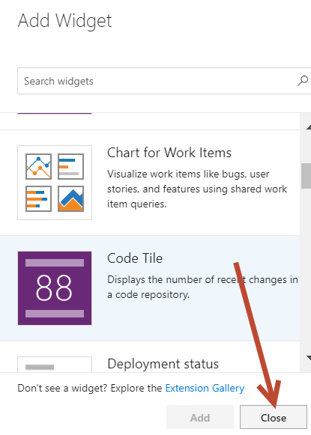

1. Click the blue checkmark to edit the widget. (if you wanted to add more widgets you would hit the green + button above it).

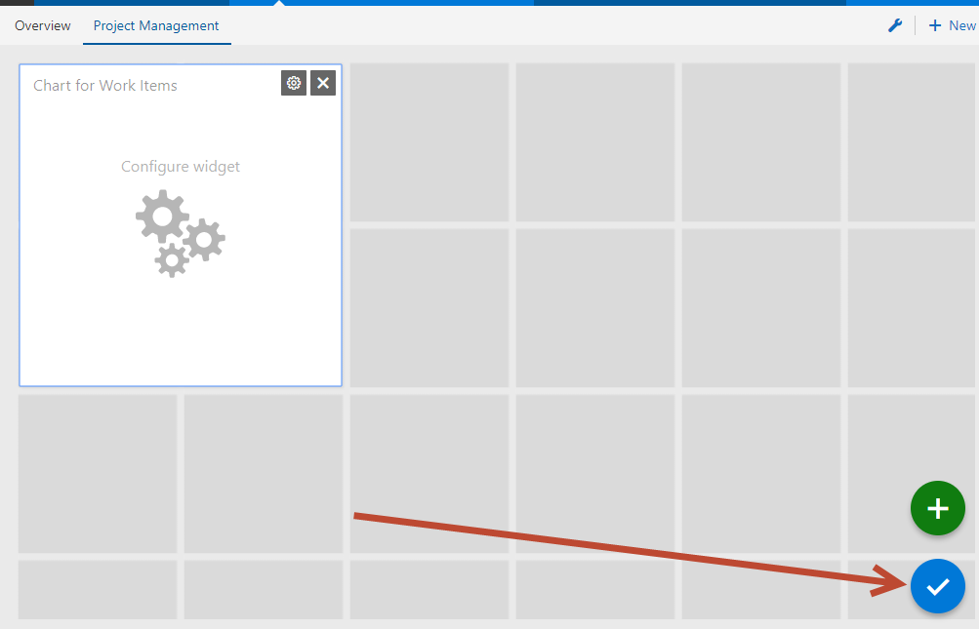

1. Click on the widget to configure it. Choose the Query from Shared Queries > Current Iteration then choose your custom query **Incomplete Tasks**.

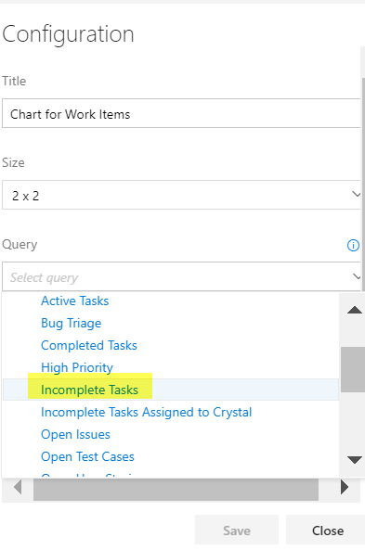

1. Choose a Pie Chart and to Group by Assigned to. Hit Save.

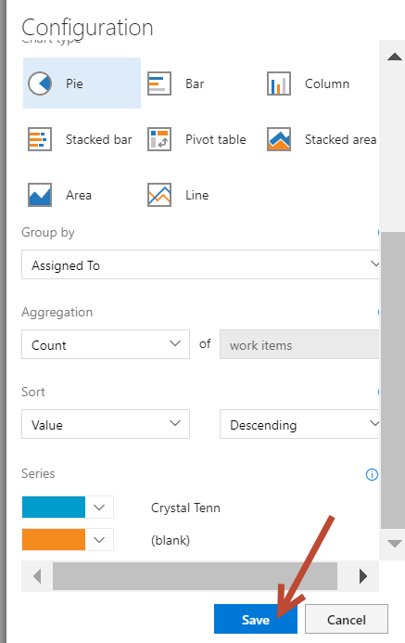

1. You will see the following widget now:

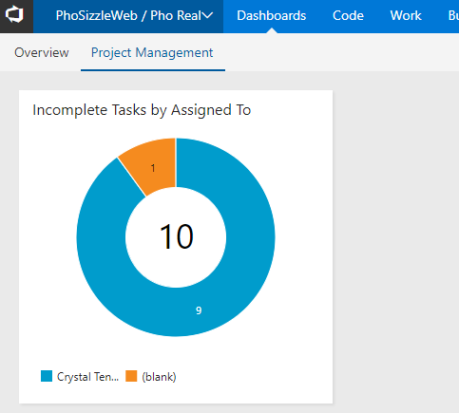

1. On the bottom right of the screen, click on the blue pencil edit button.

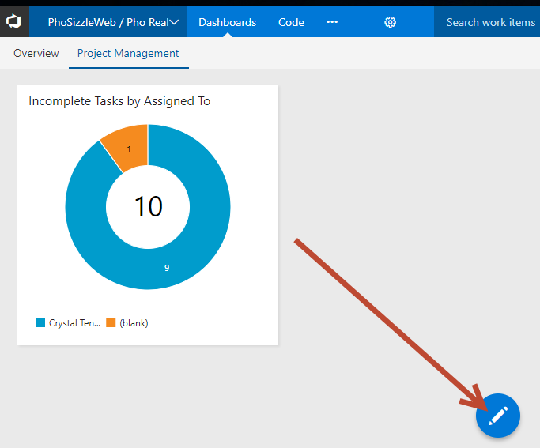

1. When you mouseover the blue button, the green + button will show up and you can add more charts.
2. Using the same “Chart for Work Items” widget, create 3 more different types of charts and add them to this Dashboard.

**2. Creating Wiki Pages**

1. Click on the Wiki page link (stay in the Pho Real team, Wikis are Team based).

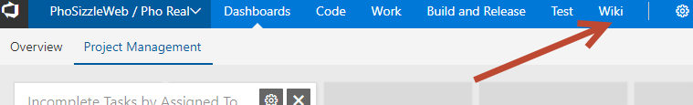

1. Click on “Create Wiki”.
2. Let’s add some basic text to learn how to use MarkDown. Add a title “Welcome to the Team”. Copy and paste the following into the text:

Header Large

Header Medium

Bolded Text

Italics

Link Here

Code

Bullet 1

Bullet 2

Bullet 3

Numbered List Item 1

Numbered List Item 2

Task List 1

Task List 2

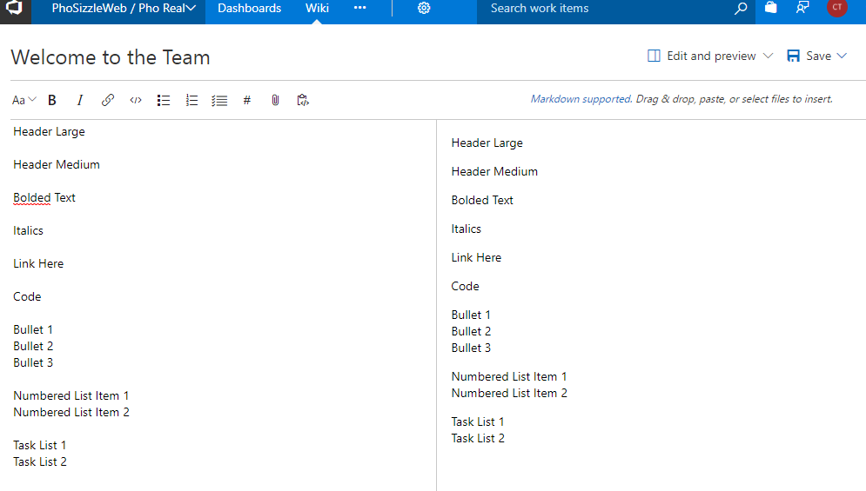

1. When you paste the text in, it will look like the screenshot above. Now let’s add Markdown in. Take the Header Large text and highlight it. While it is highlighted, click the Aa button and choose Header 1.

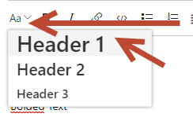

1. You will see it edited the preview on the right, and added a ‘#’ sign to your header.

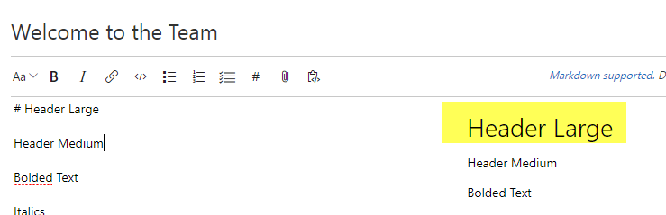

1. On Header Medium, type in two ‘##’ before the header like this:

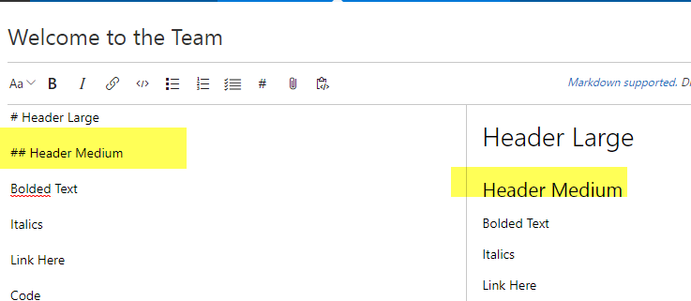

1. Highlighted the bolded text and click the **B** button:

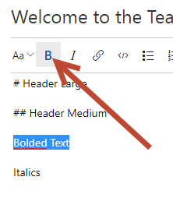

1. Continue to select the “Italics” text, and hit the italics button.. and so on to the rest of the text until your file looks just like this:

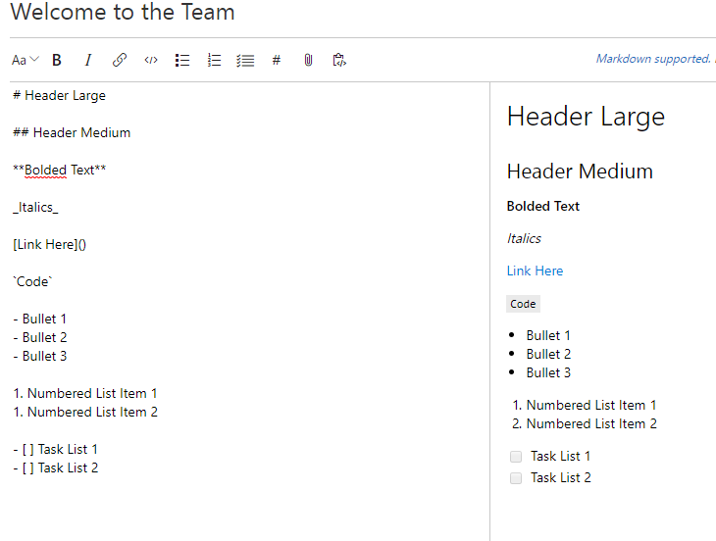

1. Hit Save on the top right.

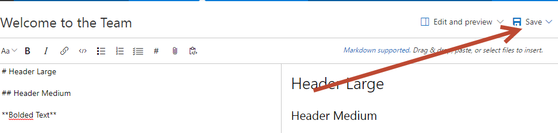

1. Once it is saved, click the Close button on the top right. Now you land on the main Wiki page. Create a new page:

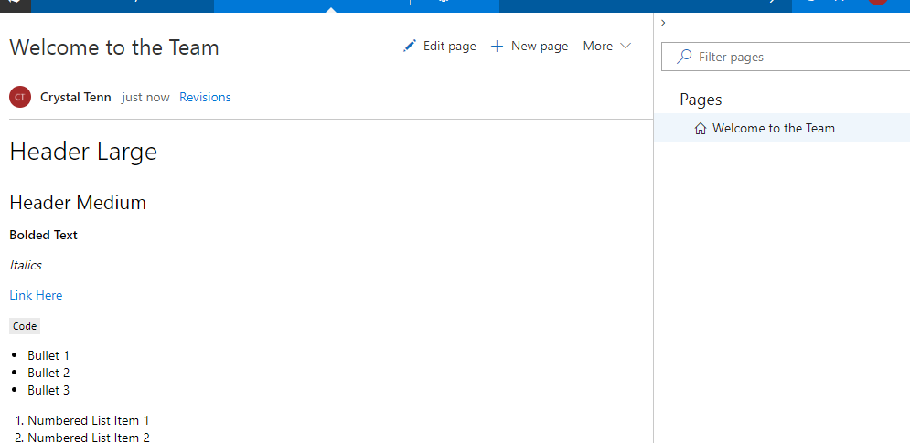

1. Call the new page Onboarding and copy paste some random text into it, save it, and close it. You should see both pages on the right now in your Wiki:

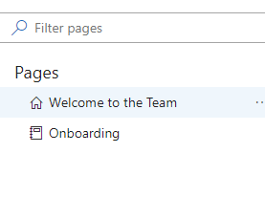

**3. Delivery Plan**

1. Go to this URL: <https://marketplace.visualstudio.com/items?itemName=ms.vss-plans>
2. You need to hit Install to add the Delivery Plan extension to your VSTS. While the feature is a VSTS feature, you need the Extension to be able to use it.
3. Choose your correct account, hit Continue:

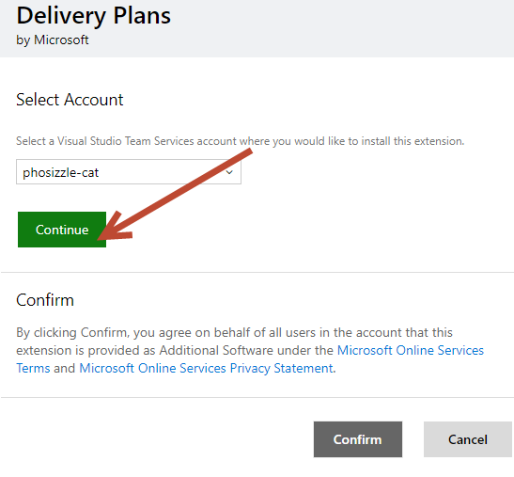

1. Click on Confirm once it is done.
2. You can see your project Extensions by going to the project level (above the teams), click the settings gear, then click Extensions.

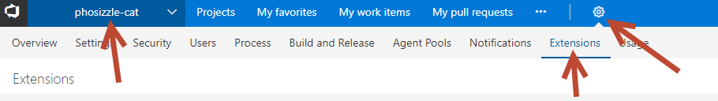

1. Go back into your Pho Real team and click the Work tab. Then click on your brand new Plans tab.

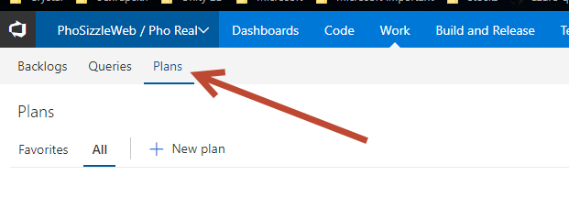

1. Click New Plan. Add all 3 of your Teams like the screenshot, choose Backlog level to be Stories. *Note the Mobile team Kanban won’t show up, but this is just to illustrate what happens if you add a Kanban team.

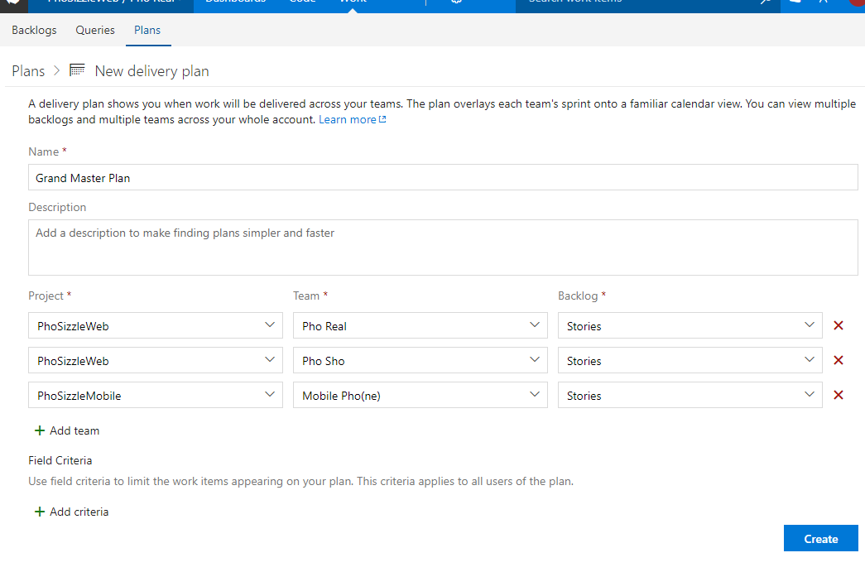

1. This is what your Plan should look like: it will show you dates and sprint numbers. You can expand individual rows to see specific stories in the teams. The Kanban board will not show, you need to have Iterations to show up on the board. Stay on this page for the next set of exercises.

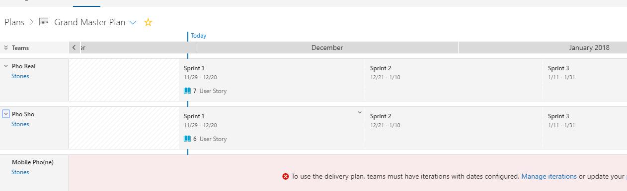

**4. Favoriting and Watching**

1. While you are on the Plan board, click on the little star at the top: This will add it to your favorites.

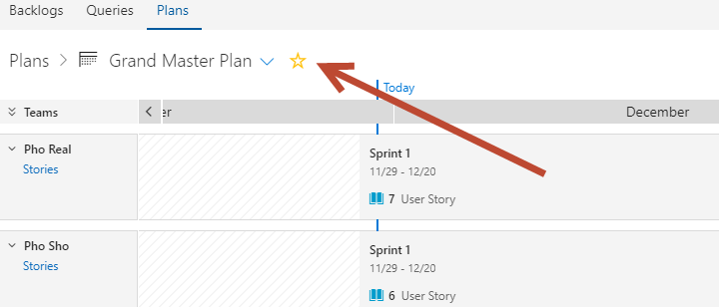

1. Click on Backlogs and Board. Click on a user story, task, and bug and hit Follow on all 3:

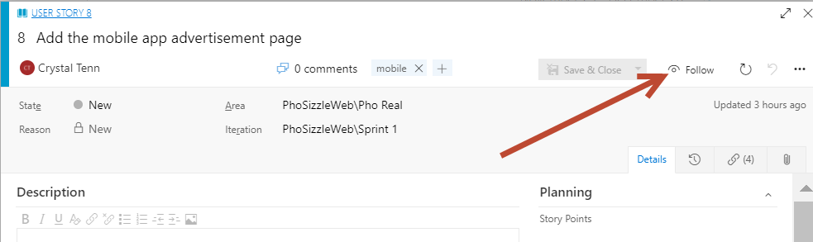

1. Click on the logo on the top left.

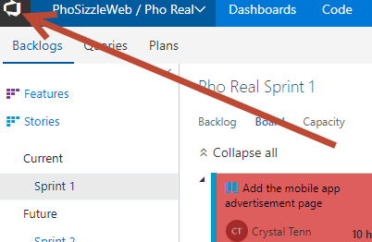

1. On My Work Items, Click Following. You should see your User Story, Task, and Bug that you Followed. You can click the eye icon on the right side to unfollow. You can click on the entry to get to it quickly.

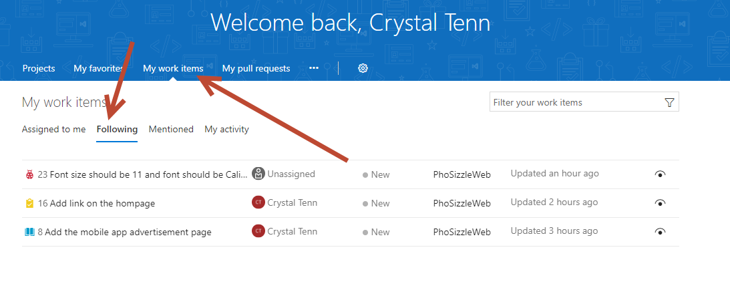

1. Click on My Favorites. You should see your plan show up here. You can unfavorite by clicking the star, and get to it quicker clicking on the row here.

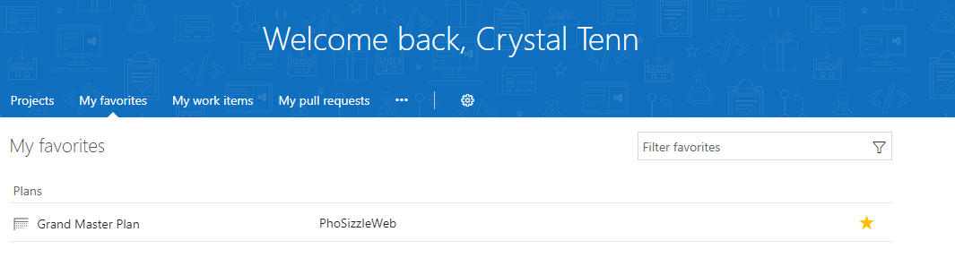

1. Let’s try filtering. Go to My work items again, then hit Assigned to me. User the filter on the top right to search for “rest”, which is just short for “restaurants”,

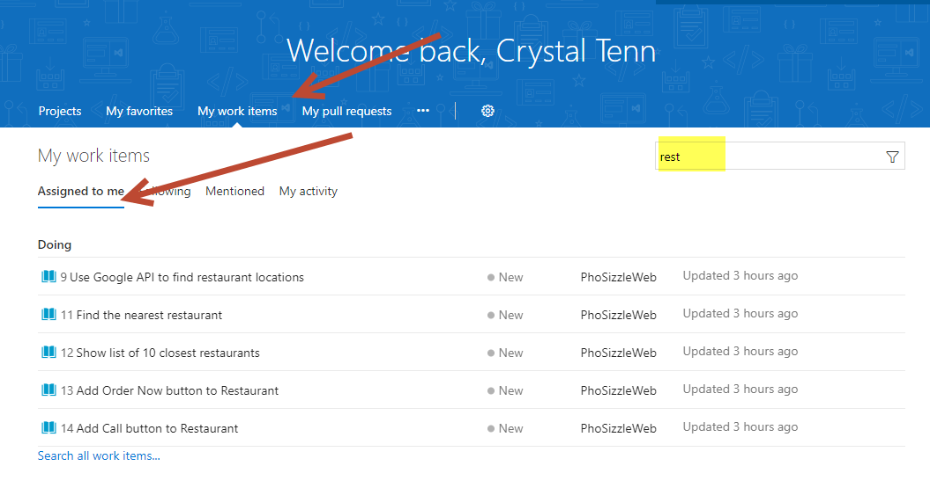

1. Try filtering on other words to find your work items. ‘
2. When you are done exploring your custom page, you are done with this exercise.

Exercise 9: Setup Notifications (10 mins)

Pho Sizzle wants all of their team members (that’s only you!) to setup notifications for when work items you created are changed, when a work item is deleted, and when a work item is restored.

Tasks

1. Setup Notifications
2. Mouseover your icon on the top right and choose Notification Settings.

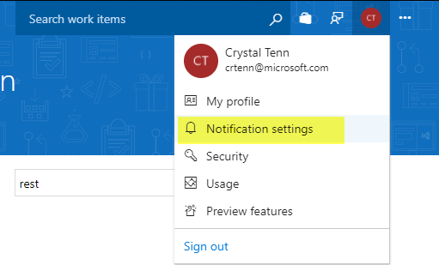

1. Read through the possible notification options and choose whichever ones you think you would be interested in.
2. Click New Subscription on the top and subscribe yourself to 3 new topics (when work items you created are changed, when a work item is deleted, and when a work item is restored).

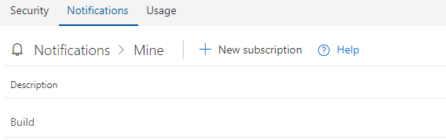

1. When you are done, you have completed this exercise.

Exercise 10: PREVIEW Features, Requesting Features, Roadmap (10 mins)

Pho Sizzle wants you to try out the new Preview features. They also want to know what’s on the roadmap and how to request new features from the VSTS team!

Tasks

1. Setup PREVIEW, find roadmap, and new features
2. Mouseover your icon on the top right and choose Preview Features. These will change over time! And the stuff that used to be in Preview, will be implemented 😊.

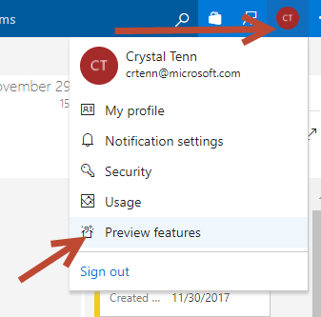

1. Try turning on some of the features such as Work Item and Queries.

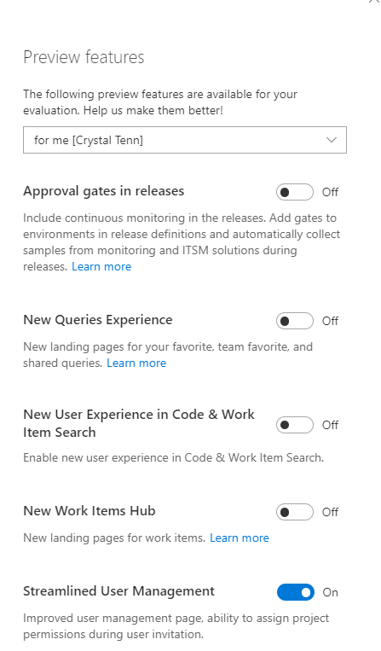

1. Click on the Work tab, then visit the new Work Item and Queries page and note the differences! Spend around 5 minutes checking out these features.
2. Click here to go to the Roadmap: <https://docs.microsoft.com/en-us/vsts/release-notes/>
3. Click here to go to the VSTS UserVoice Site: <https://visualstudio.uservoice.com/forums/330519-visual-studio-team-services>

Exercise 11: Advanced Scenario: Help the team out with some custom requests! (30 mins)

Pho Sizzle’s complicated team Pho Real wants you to be their Consultant to help them customize their VSTS! They think you’ve learned the ropes and can make some complex stuff happen for them! Help them out with the following tasks! You are allowed to look back in this guide, use the Internet, use your friends… and if you get really stuck, you can even use your Instructor for help!

Remember, all of these tasks are for the Pho Real team and should be in the scope of their team project!!!

Tasks

1. Advanced Scenarios
2. Go to the Visual Studio Marketplace and install the following into your VSTS account: <https://marketplace.visualstudio.com/items?itemName=ms-devlabs.WorkItemVisualization> and <https://marketplace.visualstudio.com/items?itemName=ms-devlabs.estimate>

Once they are both installed, find a work item, hit the “…” and find Visualize in the dropdown near the bottom. Try visualizing the links between different work items. Then under the Work tab, find the Estimate tab. Try using this to assign points to a story.

1. Pho Real wants you to change them from the Agile (default) process to another new Custom Process off the Agile one, separate from all the existing ones. After you do that, they want to add another User Story State called: “Requirements Writing”.
   1. *hint! To find the Process tab you need to be in the main project level (ABOVE all of the teams), in my example that was phosizzle-cat
2. On the board, make it so that the User Story cards show their ID on the card and an additional field for Board Column.
3. Someone in Pho Real decided they wanted to take a 3-week vacation (sweet! The length of the sprint!) so now you need to push work to another team. Push half of your Sprint 1 user stories into the Pho Sure team. Now transfer 1 work item to the Mobile team, just for fun.
4. A dev *really* likes one of your templates (pick any one you want) and wants you to add the URL for it to the Dashboard. Create a widget on the Dashboard that lists “Useful template URLs” and has one link to a template listed.
5. Go to the main phosizzle VSTS account on the top left. Click on the Settings Gear and go to Security. Think about where the following groups of people would be sorted into: DevOps, Product Owner, Devs, and Project Management. Who in your company would be in charge of the VSTS administration and creating new accounts and projects?